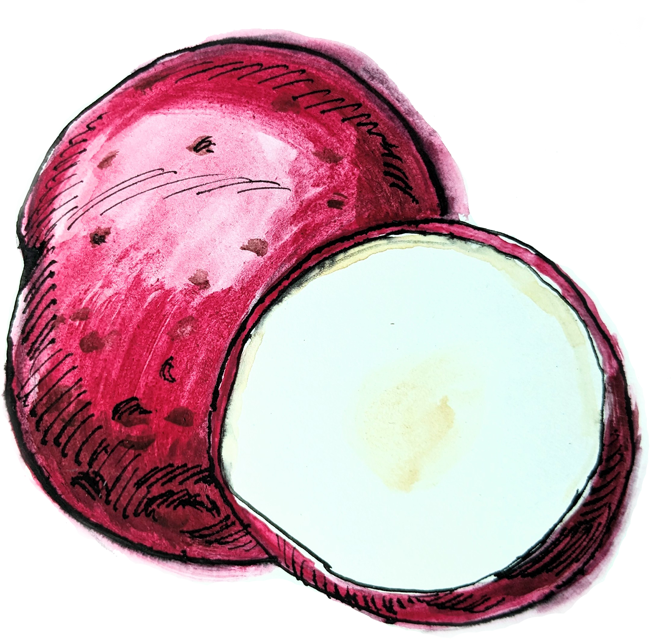**Macintosh HD:Users:F2SCoordinator:Documents:MT Team Nutrition:Grants:TN Grants:2014 - 16:2.1 Harvest of the Month:HOM Launch:HOM Launch Packaged Files:Apples:MTHOM_Apples_Cafeteria:Links:MTHOM_LOGO-apples.eps**

Cottage Pie

*Source: healthyschoolrecipes.com*

*Servings* 6

*Ingredients*

|  |  |
| --- | --- |
| 3/4 tsp Garlic, *minced*  1/4 Small Onion, *chopped*  1/2 cup Carrots, *chopped 1/4 inch dice*  1 Tbsp Vegetable Oil  1 Tbsp Flour  1 lb Ground Beef  1 cup Beef Broth  1 15oz can Canned Corn | 1.5 lbs Red Potatoes  1 tsp Granulated Garlic  1/2 cup Nonfat Milk  1 Tbsp Butter  1/4 tsp Kosher Salt  1/4 tsp Black Pepper  1 Tbsp Fresh Parsley, *chopped* (optional) |

*Preparation*

|  |
| --- |
| 1. Cook and drain ground beef. Set aside.  2. Sauté chopped onions and carrots in oil for 15 minutes, or until the onions begin to brown. Add garlic and sauté for about a minute longer.  3. Add the flour and stir over medium heat for about three minutes. Do not burn the flour, but it should brown.  4. Add broth gradually. Add beef, and simmer for 30 minutes.  5. Meanwhile, simmer potatoes in a steam kettle or large pot of water until the largest potatoes are fork-tender, about 30 minutes.  6. Spread meat mixture in greased baking dish.  7. Drain corn and spread over meat mixture.  8. Heat milk to a near boil, being careful not to allow the milk to boil over and stirring occasionally to prevent burning.  9. Add butter, garlic, salt, and black pepper to the milk.  10. Drain potatoes and place into mixing bowl.  11. Whisk in hot milk mixture at the slowest speed, gradually increasing the speed until smooth. (Do not mix too long or the potatoes will cool.)  12. Spread mashed potatoes over corn and meat.  13. Bake in 350°F oven until the center reaches 160°F, around 30 minutes.  Dig Deeper  For information recipes, lessons, resources, guides, and more, visit:  **mtharvestofthemonth.org** |