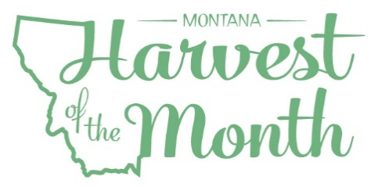
May 2025
Your School Name/Logo

Monday | Tuesday | Wednesday | Thursday | Friday
 |  |  | 1  Write Here | 2  Write Here
5  Write Here | 6  Write Here | 7  Write Here | 8  Write Here | 9  Write Here
12  Write Here | 13  Write Here | 14  Write Here | 15  Write Here | 16  Write Here
19  Write Here | 20  Write Here | 21  Write Here | 22  Write Here | 23  Write Here
26  Write Here | 27  Write Here | 28  Write Here | 29  Write Here | 30  Write Here
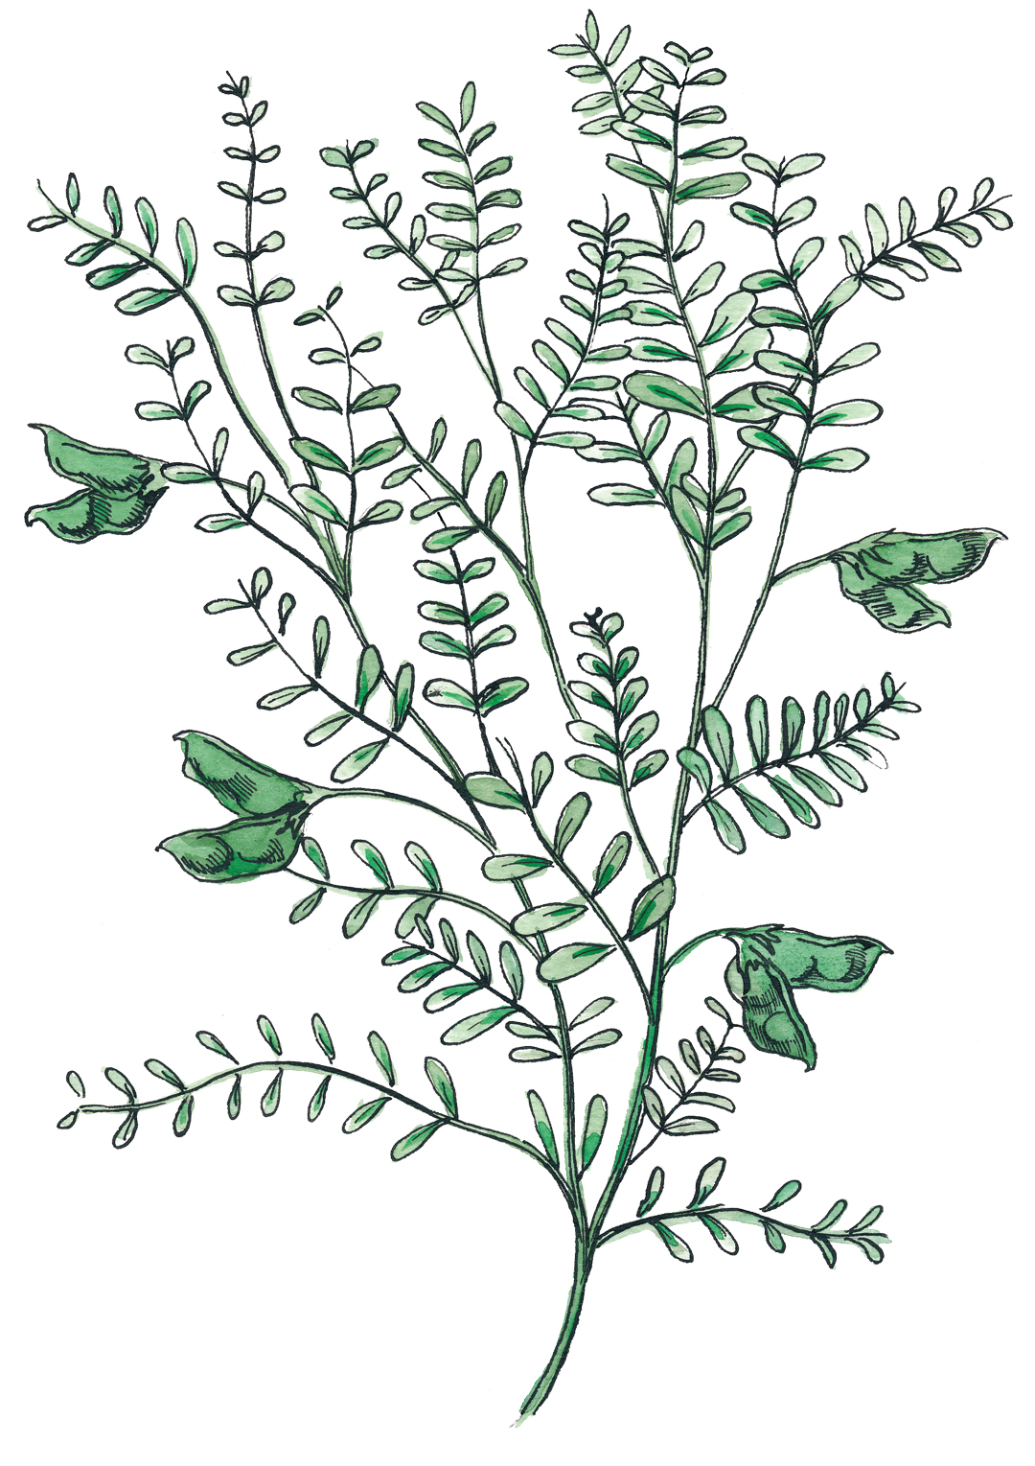
Lentils are this month’s Harvest of the Month food. Did you know…
- Lentils are in the protein and vegetable food groups and were one of the first crops cultivated by humans.
- Montana is the top producer of lentils in the United States, producing almost 40% of the lentils grown in this country!
- Like other legumes, lentils add nitrogen to the soil, improving soil health. This makes them a good rotational crop with wheat and other grains.
To learn more about Montana Harvest of the Month visit:
https://mtharvestofthemonth.org/

