Your School Name/Logo
December 2024

Monday | Tuesday | Wednesday | Thursday | Friday
2  Write Here | 3  Write Here | 4  Write Here | 5  Write Here | 6  Write Here
9  Write Here | 10  Write Here | 11  Write Here | 12  Write Here | 13  Write Here
16  Write Here | 17  Write Here | 18  Write Here | 19  Write Here | 20  Write Here
23  Write Here | 24  Write Here | 25  Write Here | 26  Write Here | 27  Write Here
30  Write Here | 31  Write Here
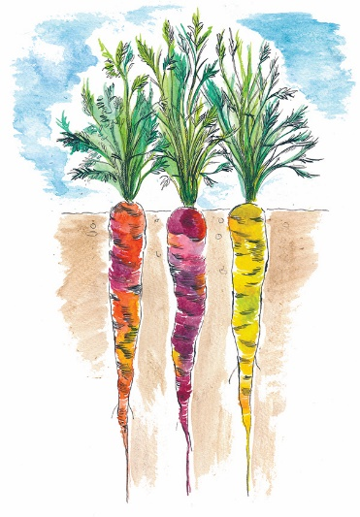
Carrots are this month’s Harvest of the Month. Did you know…
- Carrots are in the vegetable food group.
- Today carrots come in many colors including purple, black, yellow, orange, red, and white and also range in size from a round 2-inch carrot to a slender 3-foot carrot!
- The average person eats 17 pounds of carrots per year. How many pounds of carrots do you eat?
To learn more about Montana Harvest of the Month visit:
https://mtharvestofthemonth.org/

