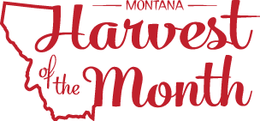

Greetings,
Our school is participating in Montana Harvest of the Month (mtharvestofthemonth.org). Each month, our school along with other participating schools, afterschool programs, early care and education sites, and healthcare facilitates throughout Montana will showcase one locally or Montana grown or raised food by a) serving it in a meal or snack, b) offering taste tests to students, and c) doing educational activities. The two primary goals of the program are to promote local, healthy foods to Montanans, and to support Montana farmers, ranchers, and food businesses.

Watch the school menu and information sent home with students for more information about the Harvest of the Month foods being featured. We encourage you to ask your child about Harvest of the Month foods and prepare these foods at home during the month that they are promoted. Research has shown that children can try a food up to twenty times before they “like” that food, which means that providing as many opportunities as possible to try new foods is crucial to building healthy eating habits and adventurous eaters. This school year, we will feature the following foods:
- August - Cherries
- September - Herbs
- October - Brassicas
- November – Apples
- December - Carrots
- January - Lentils
- February - Beets
- March - Grains
- April - Beef + Bison
- May - Chickpeas
- June - Leafy Greens
- July – Summer Squash
We welcome your help during taste tests and educational activities. Please inquire with your child’s teacher about these and other opportunities to dig in. We hope you join us in this opportunity to promote healthy eating and strong economies.

Updated June 27, 2023

