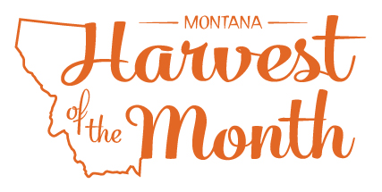
Your School Name/Logo
Month Year

Monday | Tuesday | Wednesday | Thursday | Friday
X  Write Here | X  Write Here | X  Write Here | X  Write Here | X  Write Here
X  Write Here | X  Write Here | X  Write Here | X  Write Here | X  Write Here
X  Write Here | X  Write Here | X  Write Here | X  Write Here | X  Write Here
X  Write Here | X  Write Here | X  Write Here | X  Write Here | X  Write Here
X  Write Here | X  Write Here
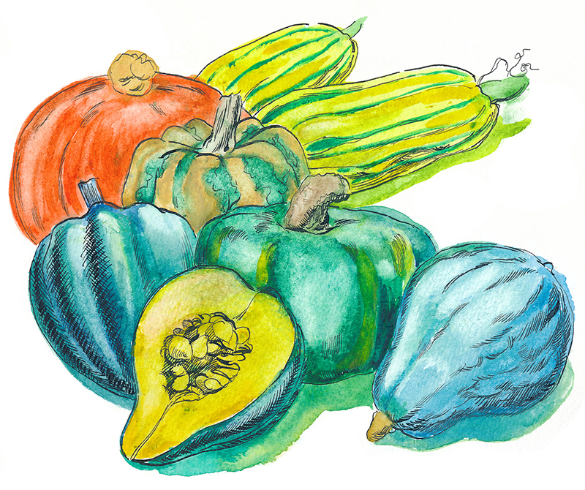
Winter squash are this month’s Harvest of the Month food. Did you know…
- Winter squash are in the vegetable food group.
- Squash is one of the oldest cultivated crops in the Western Hemisphere and was originally grown for its seeds. Seeds found in Mexico have been dated as 10,000 years old!
- To some Native American tribes, corn, beans, and squash are known as the “Three Sisters.” These plants were grown together and were staples of many tribes in North America.
To learn more about Montana Harvest of the Month visit:
https://mtharvestofthemonth.org/

