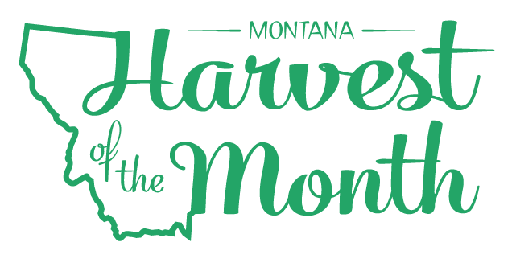
July 2024
Your School Name/Logo

Monday | Tuesday | Wednesday | Thursday | Friday
1  Write Here | 2  Write Here | 3  Write Here | 4  Write Here | 5  Write Here
8  Write Here | 9  Write Here | 10  Write Here | 11  Write Here | 12  Write Here
15  Write Here | 16  Write Here | 17  Write Here | 18  Write Here | 19  Write Here
22  Write Here | 23  Write Here | 24  Write Here | 25  Write Here | 26  Write Here
29  Write Here | 30  Write Here | 31  Write Here
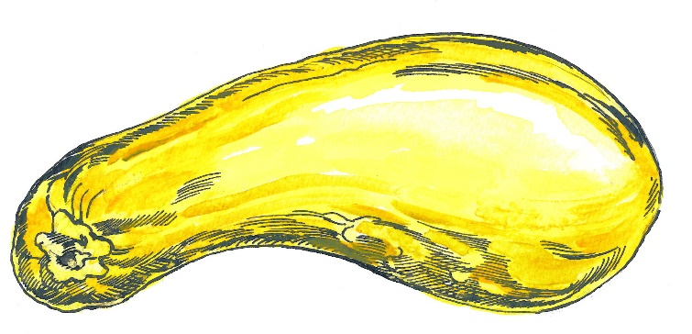
Summer Squash are this month’s Harvest of the Month. Did you know…
- Summer squash are in the vegetable food group.
- Zucchini is the most common variety of summer squash. Summer squash are harvested in the summer and have thin skins and soft flesh. Winter squash, on the other hand, are harvested later in the season and have thick rinds.
- Summer squash are members of the Cucurbitaceae (Cucurbit) family, which includes melons, pumpkins, cucumbers, and gourds.
To learn more about Montana Harvest of the Month visit:
https://mtharvestofthemonth.org/

