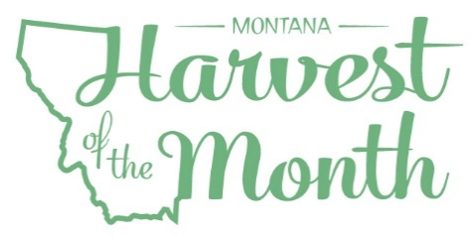
January 2024
Your School Name/Logo

Monday | Tuesday | Wednesday | Thursday | Friday
1  Write Here | 2  Write Here | 3  Write Here | 4  Write Here | 5  Write Here
8  Write Here | 9  Write Here | 10  Write Here | 11  Write Here | 12  Write Here
15  Write Here | 16  Write Here | 17  Write Here | 18  Write Here | 19  Write Here
22  Write Here | 23  Write Here | 24  Write Here | 25  Write Here | 26  Write Here
29  Write Here | 30  Write Here | 31  Write Here
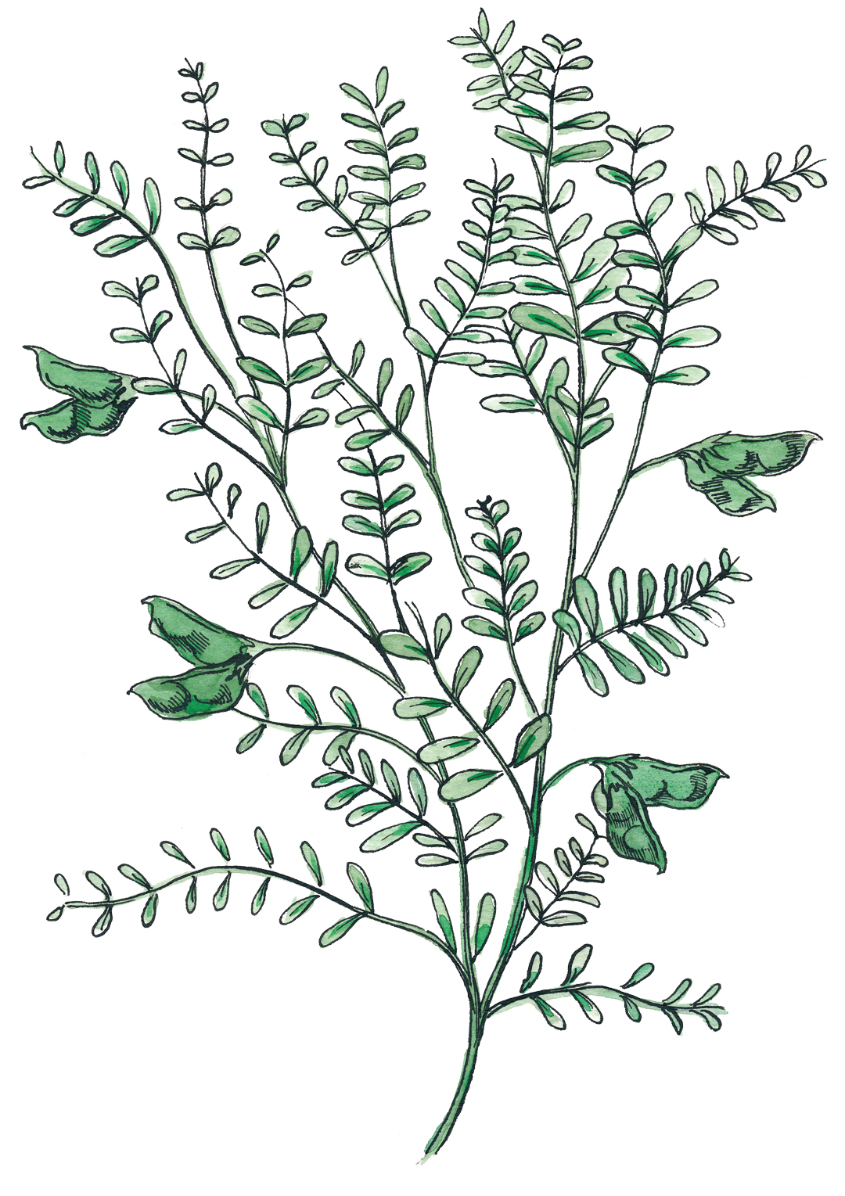
Lentils are this month’s Harvest of the Month food. Did you know…
- Lentils are in the protein and vegetable food groups and were one of the first crops cultivated by humans.
- Montana is the top producer of lentils in the United States, producing almost 40% of the lentils grown in this country!
- Like other legumes, lentils add nitrogen to the soil, improving soil health. This makes them a good rotational crop with wheat and other grains.
To learn more about Montana Harvest of the Month visit:
https://mtharvestofthemonth.org/

