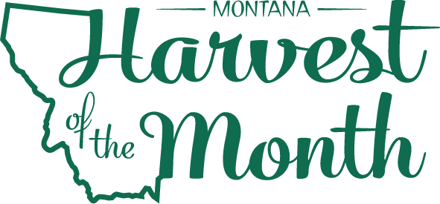
June 2024
Your School Name/Logo

Monday | Tuesday | Wednesday | Thursday | Friday
3  Write Here | 4  Write Here | 5  Write Here | 6  Write Here | 7  Write Here
10  Write Here | 11  Write Here | 12  Write Here | 13  Write Here | 14  Write Here
17  Write Here | 18  Write Here | 19  Write Here | 20  Write Here | 21  Write Here
24  Write Here | 25  Write Here | 26  Write Here | 27  Write Here | 28  Write Here
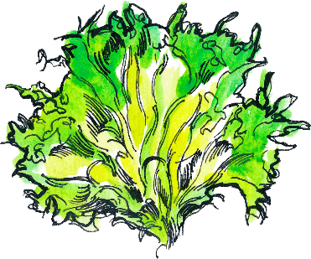
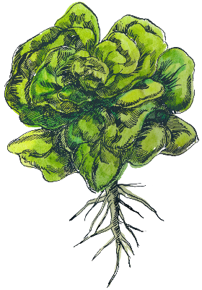
Leafy Greens are this month’s Harvest of the Month. Did you know…
- Leafy greens are in the vegetable food group.
- The average American eats about 30 pounds of lettuce every year. That’s about five times more than in the early 1900s.
- Most varieties that can be used for cooking, such as collards, kale, mustard greens, turnip greens, and bok choy, are part of the cabbage family
(Brassica).
To learn more about Montana Harvest of the Month visit:
https://mtharvestofthemonth.org/

