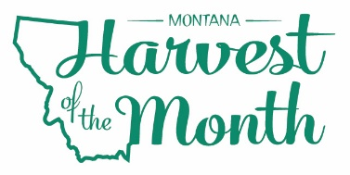
MONTH YEAR
Your School Name/Logo

Monday | Tuesday | Wednesday | Thursday | Friday
X  Write Here | X  Write Here | X  Write Here | X  Write Here | X  Write Here
X  Write Here | X  Write Here | X  Write Here | X  Write Here | X  Write Here
X  Write Here | X  Write Here | X  Write Here | X  Write Here | X  Write Here
X  Write Here | X  Write Here | X  Write Here | X  Write Here | X  Write Here
X
Write Here
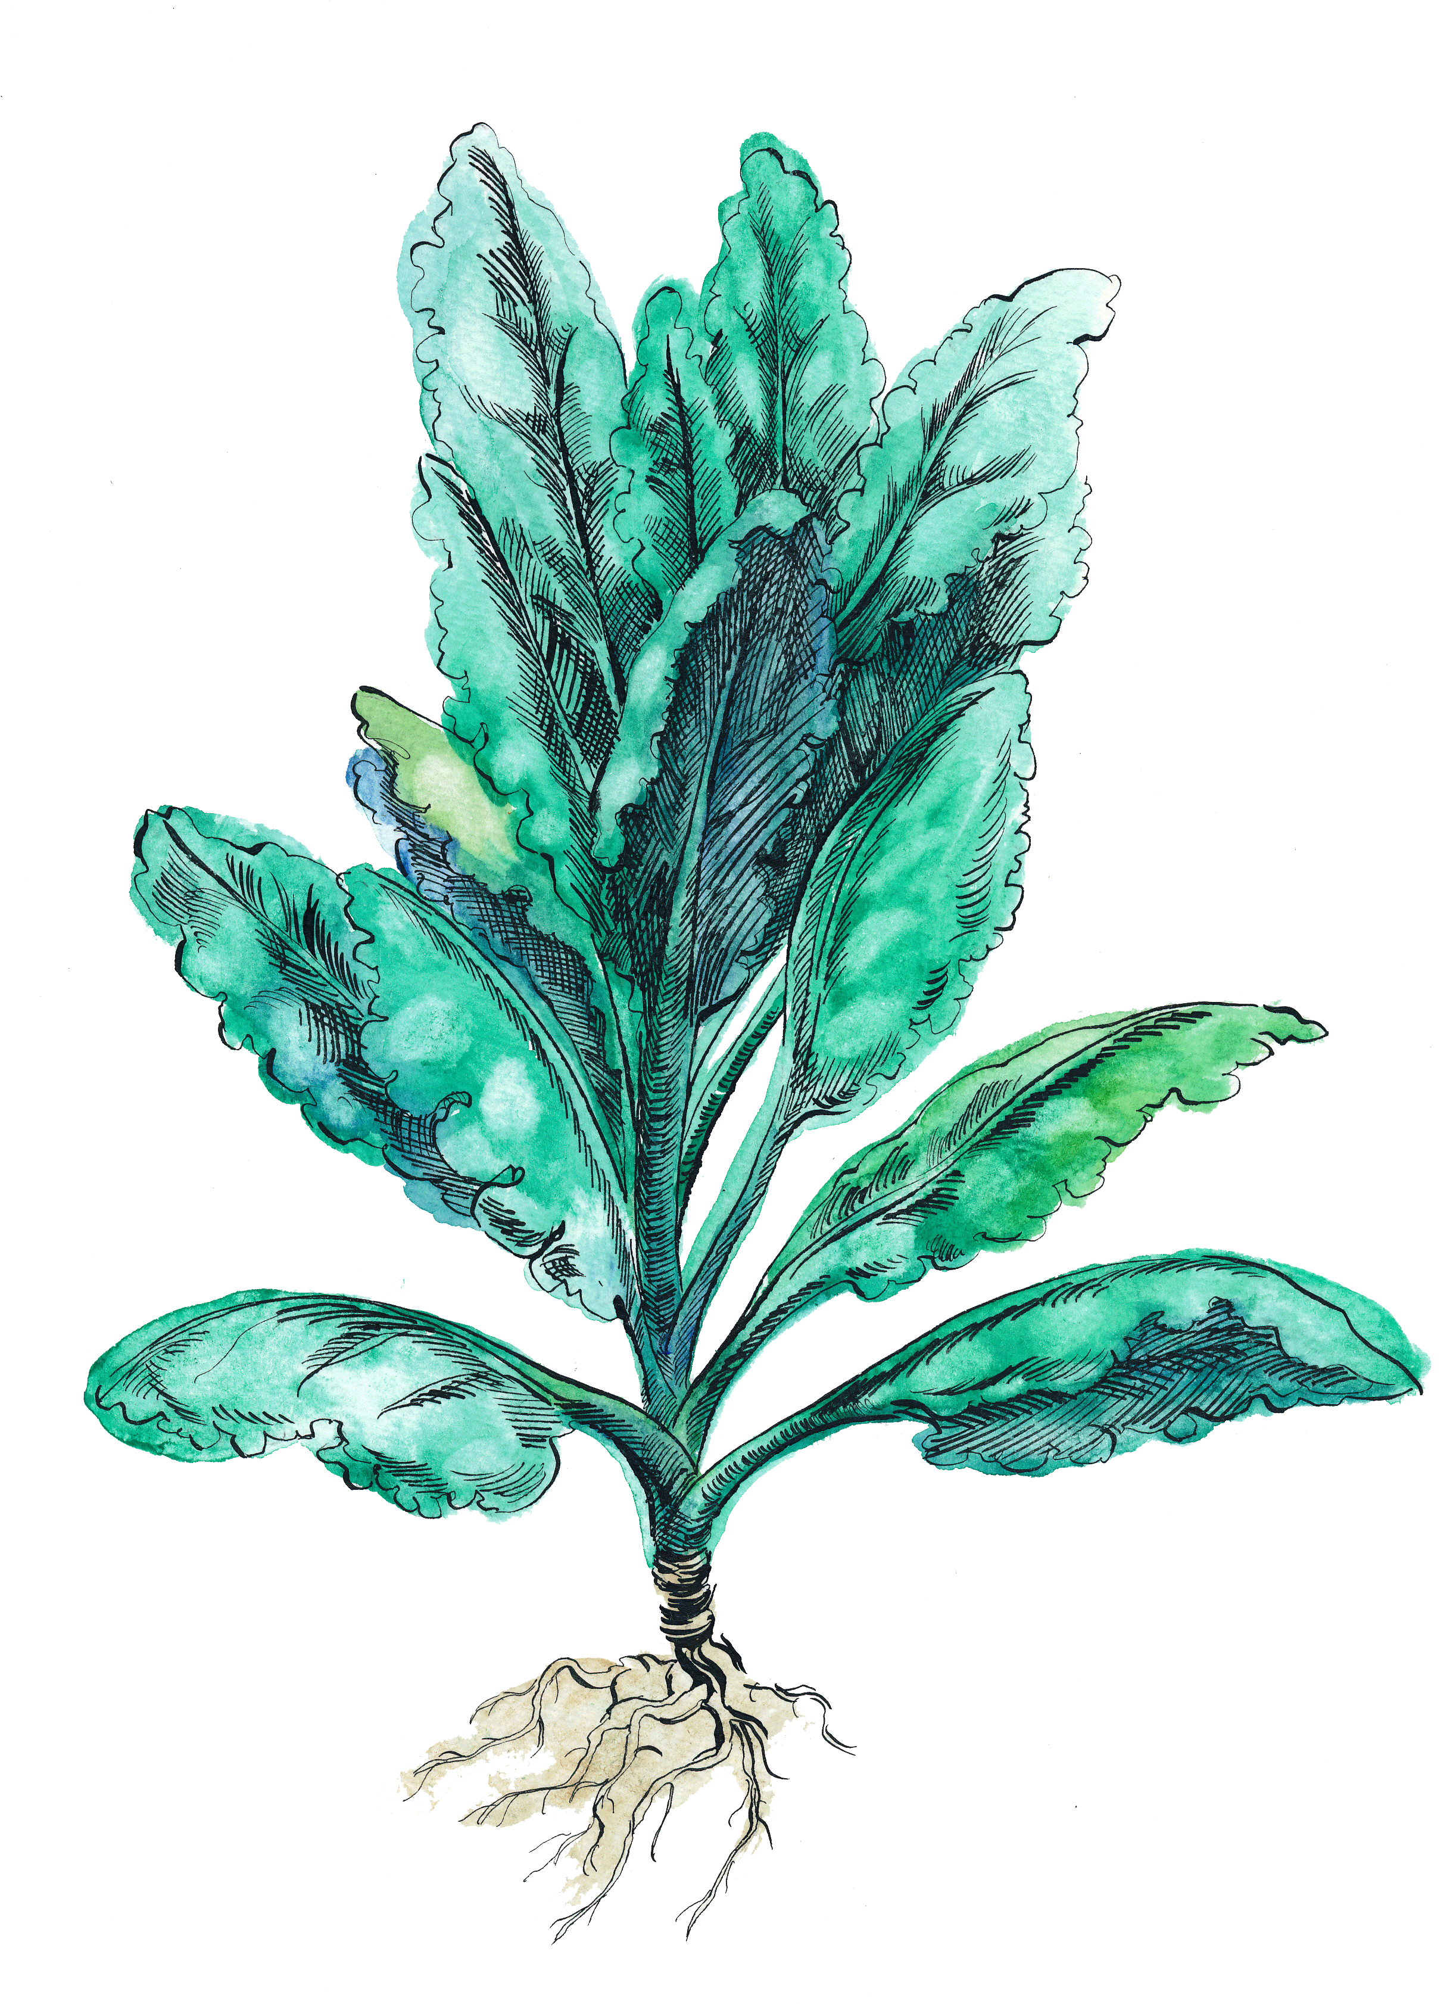
Kale is this month’s Harvest of the Month. Did you know…
- Kale is in the vegetable food group.
- Kale is packed full of nutrients. One cup of raw kale contains 684% of the recommended daily value of vitamin K, an essential nutrient that helps blood clotting. Kale is also an excellent source for vitamins A and C and provides calcium and iron.
- Kale has been grown for more than 6000 years and is in the brassica
family along with bok choy, collards, and broccoli.
To learn more about Montana Harvest of the Month visit:
https://mtharvestofthemonth.org/

