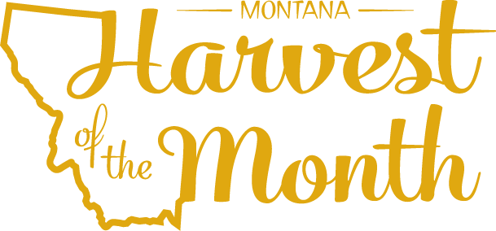
March 2024
Your School Name/Logo

Monday | Tuesday | Wednesday | Thursday | Friday
1
Write Here
4  Write Here | 5  Write Here | 6  Write Here | 7  Write Here | 8  Write Here
11  Write Here | 12  Write Here | 13  Write Here | 14  Write Here | 15  Write Here
18  Write Here | 19  Write Here | 20  Write Here | 21  Write Here | 22  Write Here
25  Write Here | 26  Write Here | 27  Write Here | 28  Write Here | 29  Write Here

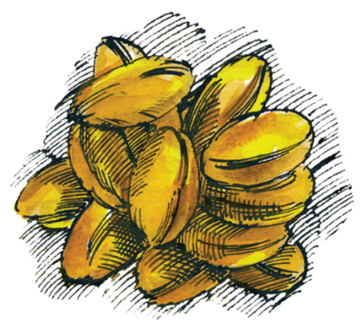
Grains are this month’s Harvest of the Month. Did you know…
- Grains make up their own food group.
- Wheat is classified by the season in which it is grown, hardness, color, and other factors. Spring wheat is planted in the spring and harvested in the late summer. Winter wheat is planted in the fall and harvested in the spring or summer, depending on the conditions.
- What’s in a bushel? One US bushel is approximately 8 gallons of dry crops.
One bushel of wheat weighs about 60 pounds.

To learn more about Montana Harvest of the Month visit:
https://mtharvestofthemonth.org/

