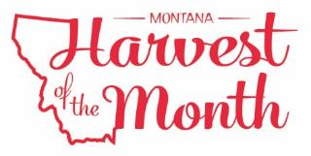
Month Year
Your School Name/Logo

Monday | Tuesday | Wednesday | Thursday | Friday
X  Write Here | X  Write Here | X  Write Here | X  Write Here | X  Write Here
X  Write Here | X  Write Here | X  Write Here | X  Write Here | X  Write Here
X  Write Here | X  Write Here | X  Write Here | X  Write Here | X  Write Here
X  Write Here | X  Write Here | X  Write Here | X  Write Here | X  Write Here
X  Write Here | X  Write Here
Dairy is this month’s Harvest of the Month. Did you know…
- There are six main dairy cattle breeds in the United States, including: Holstein, Ayrshire, Brown Swiss, Milking Shorthorn, Guernsey, and Jersey. The Holstein cow produces the most milk of all breeds, about nine gallons of milk per day!
- In 2015, Montana was home to approximately 13,000 dairy cows on nearly 65 dairy farms. The average herd size was about 210 cows in Montana.

To learn more about Montana Harvest of the Month visit: https://mtharvestofthemonth.org/

