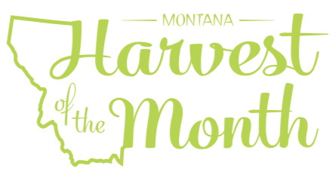
May 2024
Your School Name/Logo

Monday | Tuesday | Wednesday | Thursday | Friday
 |  | 1  Write Here | 2  Write Here | 3  Write Here
6  Write Here | 7  Write Here | 8  Write Here | 9  Write Here | 10  Write Here
13  Write Here | 14  Write Here | 15  Write Here | 16  Write Here | 17  Write Here
20  Write Here | 21  Write Here | 22  Write Here | 23  Write Here | 24  Write Here
27  Write Here | 28  Write Here | 29  Write Here | 30  Write Here | 31  Write Here
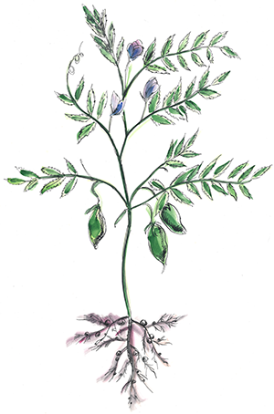
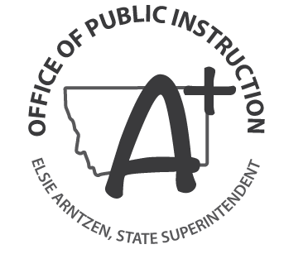
Chickpeas are this month’s Harvest of the Month. Did you know…
- Chickpeas, also called garbanzo beans, have been enjoyed as a nutritious food source for 7,000 years. The name chickpea comes from their similarity of appearance to a chick’s beak.
- Chickpeas are a nutrient powerhouse. They are an excellent source of many nutrients including potassium, calcium, iron, vitamin B-6, and magnesium.
- Montana’s production of chickpeas is growing. In 2016, Montana farmers harvested 254,000 acres of chickpeas.
To learn more about Montana Harvest of the Month visit: https://mtharvestofthemonth.org/

