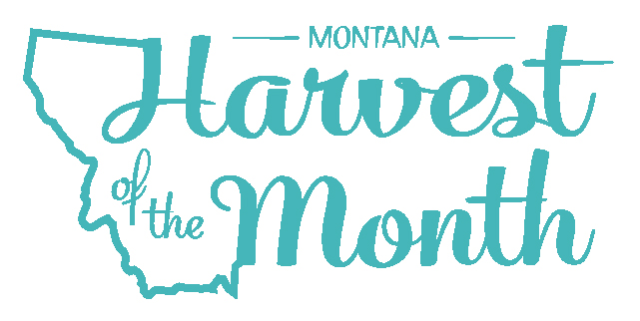
October 2023
Your School Name/Logo

Monday | Tuesday | Wednesday | Thursday | Friday
2  Write Here | 3  Write Here | 4  Write Here | 5  Write Here | 6  Write Here
9  Write Here | 10  Write Here | 11  Write Here | 12  Write Here | 13  Write Here
16  Write Here | 17  Write Here | 18  Write Here | 19  Write Here | 20  Write Here
23  Write Here | 24  Write Here | 25  Write Here | 26  Write Here | 27  Write Here
30  Write Here | 31  Write Here

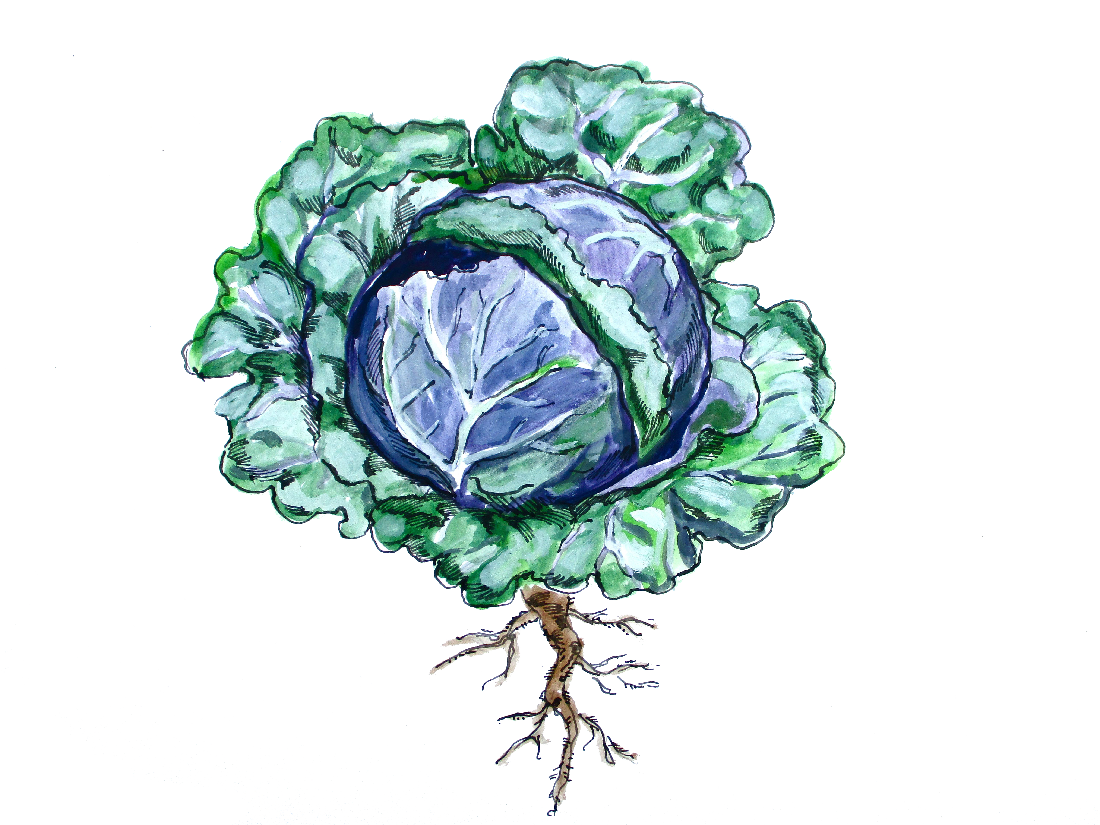
Brassicas are this month’s Harvest of the Month. Did you know…
- Brassicas are in the vegetable food group.
- “Brassica” is a genus, or group of closely related plants, in the mustard family. There are 3700+ species in the Brassica plant family, ranging from cabbage to kohlrabi.
- Although the Brassica genus is extremely diverse, most Brassicas are excellent sources of vitamin C and good sources of potassium, vitamin A, and vitamin B6.
To learn more about Montana Harvest of the Month visit:
https://mtharvestofthemonth.org/

