February 2024
Your School Name/Logo

Monday |  | Tuesday |  | Wednesday |  | Thursday |  | Friday
 |  |  |  |  | 1  Write Here |  | 2  Write Here
5  Write Here | 6  Write Her |  | 7  Write Here |  | 8  Write Here |  | 9  Write Here
12  Write Here | 13  Write Here |  | 14  Write Here |  | 15  Write Here |  | 16  Write Here
19  Write Here | 20  Write Here |  | 21  Write Here |  | 22  Write Here |  | 23  Write Here
26  Write Here | 27  Write Here |  | 28  Write Here |  | 29  Write Here
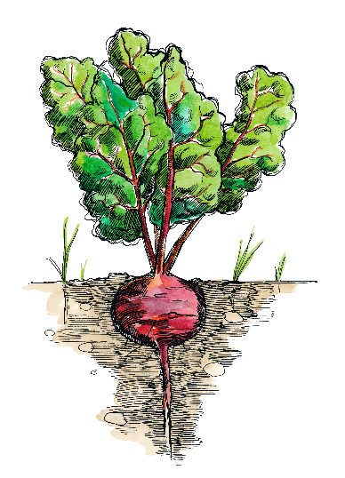
Beets are this month’s Harvest of the Month. Did you know…
- Beets are in the vegetable food group.
- While different in nutrient composition and culinary use, sugar beets are an important part of Montana’s economy. Montana is a top producer of sugar beets, harvesting nearly 1.5 million tons from 44,000 acres in 2014!
- The color of beets roots can range from dark purple to bright red, yellow or white. When cut transversely, the roots show light and dark rings, sometimes alternating. The Chioggia beet is red and white-striped and is nicknamed the “candy cane” beet.
To learn more about Montana Harvest of the Month visit:
https://mtharvestofthemonth.org/

