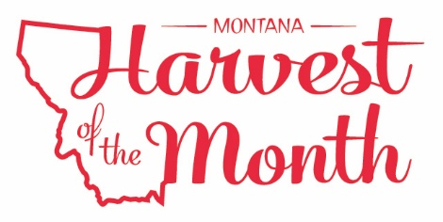

Your School Name/Logo
November 2023

Monday | Tuesday | Wednesday | Thursday | Friday
 |  | 1  Write Here | 2  Write Here | 3  Write Here
6  Write Here | 7  Write Here | 8  Write Here | 9  Write Here | 10  Write Here
13  Write Here | 14  Write Here | 15  Write Here | 16  Write Here | 17  Write Here
20  Write Here | 21  Write Here | 22  Write Here | 23  Write Here | 24  Write Here
27  Write Here | 28  Write Here | 29  Write Here | 30  Write Here
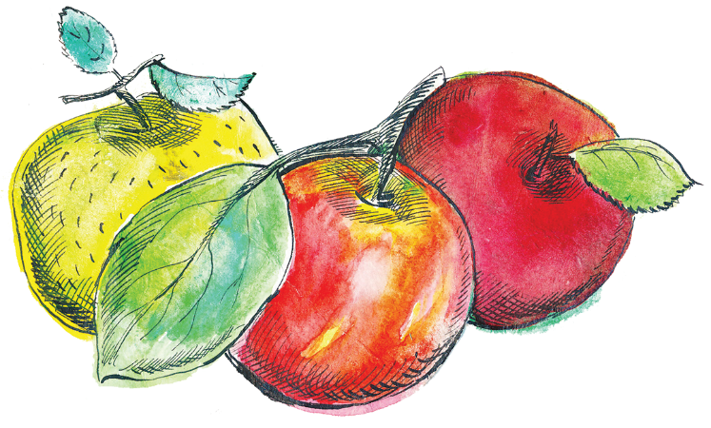
Apples are this month’s Harvest of the Month. Did you know…
- Apples are in the fruit food group.
- There are over 7,500 varieties of apples grown worldwide and 2,500 are grown in the US. However, only a handful of varieties are commonly found in grocery stores today.
- Apples were brought to the United States in the 17th century.
- The Bitterroot Valley and other areas in the western and south-central part of Montana are the largest apple producers in the state.
To learn more about Montana Harvest of the Month visit:
https://mtharvestofthemonth.org/

