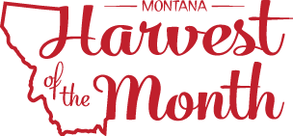

Greetings,

Our facility is participating in the new Montana Harvest of the Month program (mtharvestofthemonth.org). Each month, our facility along with other participating schools, pre-schools, afterschool programs, colleges, and grocery stores throughout Montana will showcase one locally or Montana grown or raised food by a) serving it in a meal or snack, b) offering taste tests patients and staff, and c) doing educational and promotional activities. The two primary goals for this program are to expose Montanans to local, nutritionally dense foods and to support Montana’s farmers and ranchers.

Watch the food service menu and information displayed and distributed in our facility for more information about the Harvest of the Month foods being featured. We encourage you to talk about the Harvest of the Month food and prepare these foods at home during the month that they are promoted. This year, we will feature the following foods:

- August - Cherries
- September - Herbs
- October - Brassicas
- November - Apples
- December - Dairy
- January - Lentils
- February - Beets
- March - Grains
- April - Chickpeas
- May – Beef + Bison
- June - Leafy Greens
- July – Carrots

We welcome your feedback during this pilot phase of Montana Harvest of the Month program at our facility. Please share your stories with the team by submitting your story at http://www.montana.edu/mtfarmtoschool/connect/share-story.html. We hope you join us in this opportunity to promote healthy eating and strong economies.

Sincerely,

