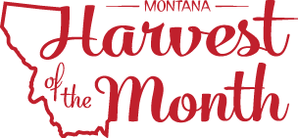

Greetings,

Our business is participating in the new Montana Harvest of the Month program (mtharvestofthemonth.org). Each month, our business along with other participating schools, pre-schools, afterschool programs, colleges, and businesses and community groups throughout Montana will showcase one locally or Montana grown or raised food by a) serving it in a meal or having it available for purchase, b) offering taste tests to students, and c) doing educational activities. The two primary goals for this program are to expose Montanans to local, nutritionally dense foods and to support Montana’s farmers and ranchers.

Watch the information displayed and distributed in our business for more information about the Harvest of the Month foods being featured. We encourage you to talk about the Harvest of the Month food and prepare these foods at home during the month that they are promoted. This year, we will feature the following foods:

- August - Cherries
- September - Herbs
- October - Brassicas
- November - Apples
- December - Dairy
- January - Lentils
- February - Beets
- March - Grains
- April - Chickpeas
- May – Beef + Bison
- June - Leafy Greens
- July - Carrots

We welcome your feedback during this pilot phase of Montana Harvest of the Month program at our business. Please share your stories with the team by submitting your story at http://www.montana.edu/mtfarmtoschool/connect/share-story.html. We hope you join us in this opportunity to promote healthy eating and strong economies.

Sincerely,

