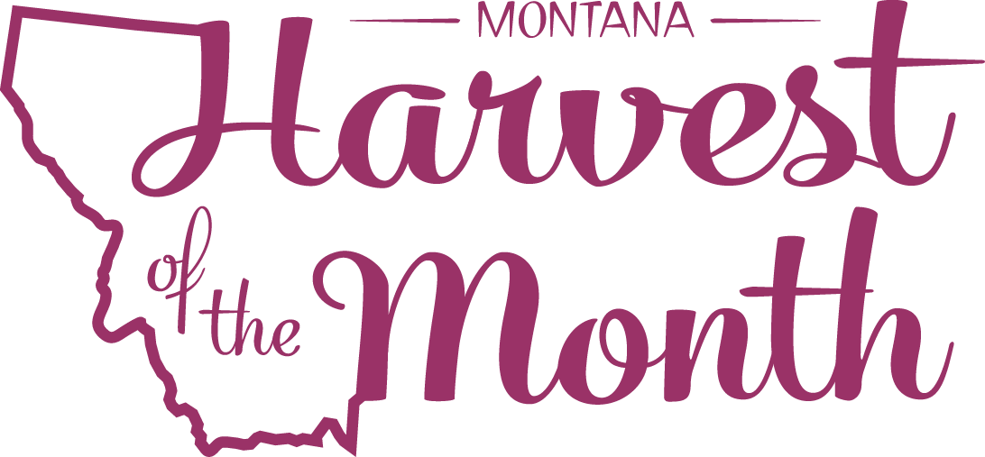
September 2022
Your School Name/Logo

Monday | Tuesday | Wednesday | Thursday | Friday
 |  |  | 1 | 2
Write Here | Write Here | Write Here | Write Here | Write Here
5 | 6 | 7 | 8 | 9
Write Here | Write Here | Write Here | Write Here | Write Here
12 | 13 | 14 | 15 | 16
Write Here | Write Here | Write Here | Write Here | Write Here
19 | 20 | 21 | 22 | 23
Write Here | Write Here | Write Here | Write Here | Write Here
26 | 27
Write Here | Write Here
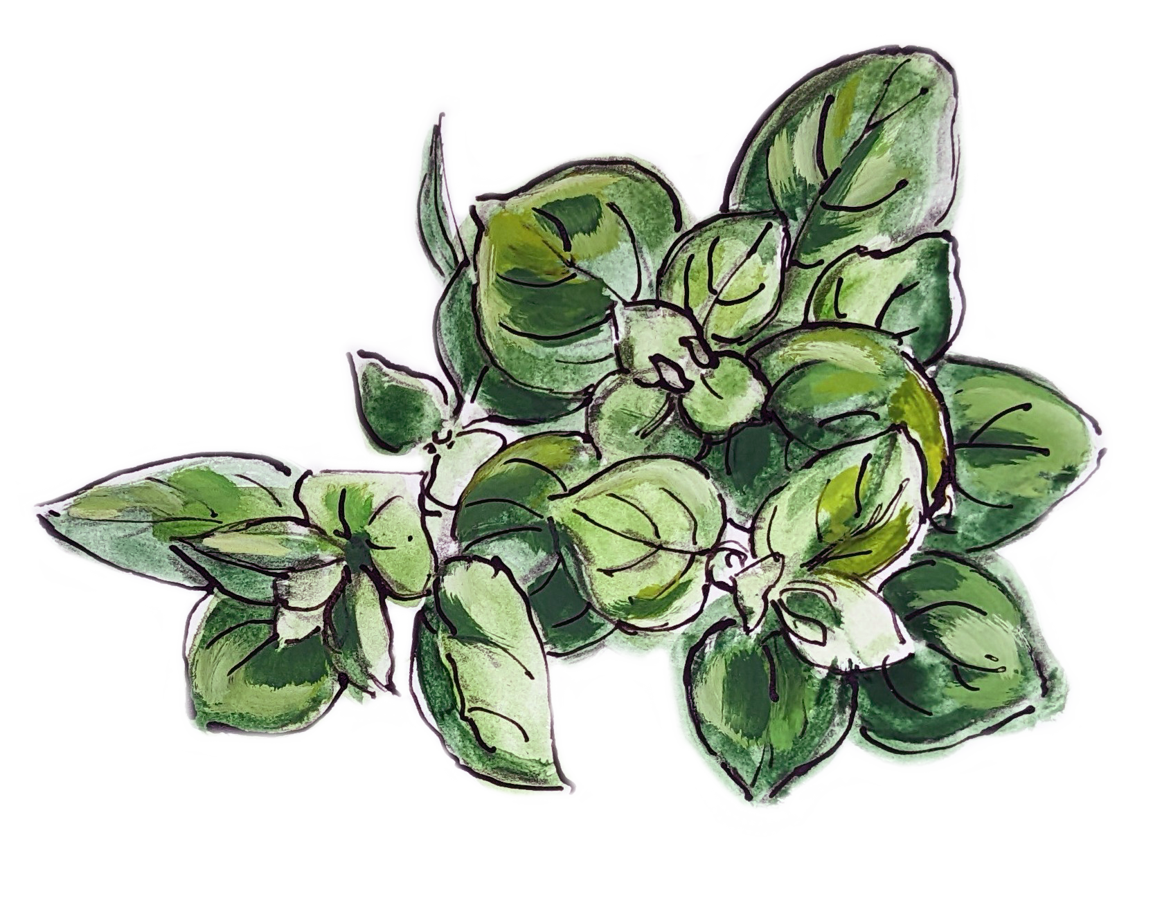
Herbs are this month’s Harvest of the Month. Did you know…
- Wild chives are native to Montana and can be found growing wildly throughout the western region of the state.
- Most herbs thrive in the garden with at least 6 hours of direct sunlight.
- Traditionally, mint tea was so commonly drunk amongst Apsaalooke (Crow) people, that one of the Apsaalooke words for “mint” is the same as the word for “tea.”
To learn more about Montana Harvest of the Month visit:
mtharvestofthemonth.org

