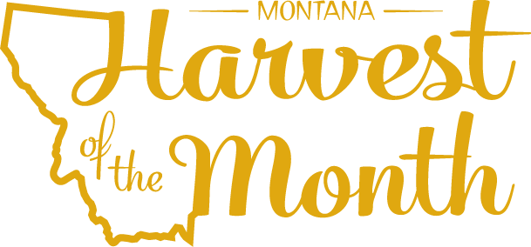
March 2023
Your School Name/Logo

Monday | Tuesday | Wednesday | Thursday | Friday
 |  | 1  Write Here | 2  Write Here | 3  Write Here
6  Write Here | 7  Write Here | 8  Write Here | 9  Write Here | 10  Write Here
13  Write Here | 14  Write Here | 15  Write Here | 16  Write Here | 17  Write Here
20  Write Here | 21  Write Here | 22  Write Here | 23  Write Here | 24  Write Here
27  Write Here | 28  Write Here | 29  Write Here | 30  Write Here | 31  Write Here

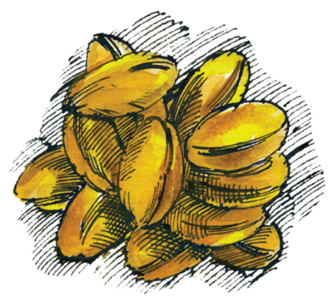
Grains are this month’s Harvest of the Month. Did you know…
- Grains make up their own food group.
- Wheat is classified by the season in which it is grown, hardness, color, and other factors. Spring wheat is planted in the spring and harvested in the late summer. Winter wheat is planted in the fall and harvested in the spring or summer, depending on the conditions.
- What’s in a bushel? One US bushel is approximately 8 gallons of dry crops.
One bushel of wheat weighs about 60 pounds.

To learn more about Montana Harvest of the Month visit:
https://mtharvestofthemonth.org/

