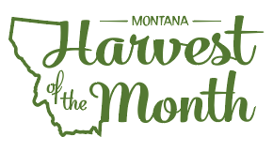
August 2022

Your School Name/Logo

Monday | Tuesday | Wednesday | Thursday | Friday
1  Write Here | 2  Write Here | 3  Write Here | 4  Write Here | 5  Write Here
8  Write Here | 9  Write Here | 10  Write Here | 11  Write Here | 12  Write Here
15  Write Here | 16  Write Here | 17  Write Here | 18  Write Here | 19  Write Here
22  Write Here | 23  Write Here | 24  Write Here | 25  Write Here | 26  Write Here
29  Write Here | 30  Write Here | 31  Write Here
Cherries are this month’s Harvest of the Month. Did you know…
- Cherries are in the rose (rosaceae) family that also includes apples and other “stone fruit” including
peaches, apricots, and plums. Stone fruit species produce fruit that has one seed, called a pit.
- On average, Montana growers produce two million pounds of sweet cherries each year. More than 640acres of sweet cherries and 90 acres of tart cherries were growing in Montana in 2017.
- Most of the sweet cherries grown in Montana are grown on the east side of Flathead Lake in Western Montana, where the climate is protected from extreme winter temperatures and spring frost.

To learn more about Montana Harvest of the Month visit: https://mtharvestofthemonth.org/

