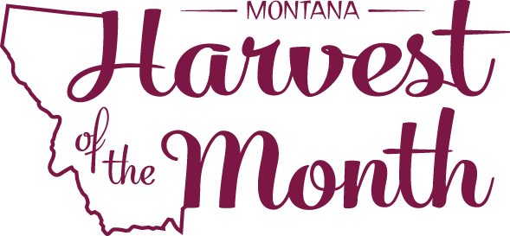
July 2023

Your School Name/Logo

Monday | Tuesday | Wednesday | Thursday | Friday
3  Write Here | 4  Write Here | 5  Write Here | 6  Write Here | 7  Write Here
10  Write Here | 11  Write Here | 12  Write Here | 13  Write Here | 14  Write Here
17  Write Here | 18  Write Here | 19  Write Here | 20  Write Here | 21  Write Here
24  Write Here | 25  Write Here | 26  Write Here | 27  Write Here | 28  Write Here
31
Write Here
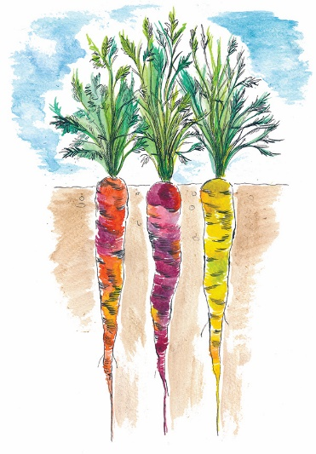
Carrots are this month’s Harvest of the Month. Did you know…
- Carrots are in the vegetable food group.
- Today carrots come in many colors including purple, black, yellow, orange, red, and white and also range in size from a round 2-inch carrot to a slender 3-foot carrot!
- The average person eats 17 pounds of carrots per year. How many pounds of carrots do you eat?
To learn more about Montana Harvest of the Month visit:
https://mtharvestofthemonth.org/

