**Montana Harvest of the Month logo**

Newsletter + Social Media Content

Winter Squash

Instructions

Please adapt and use the verbiage, logos, and images included below for your newsletter, staff announcements, menus, social media posts, etc. To use the verbiage below, please copy and paste the desired language into your document or social media platform. Be sure to add your site-specific information in the sections with {brackets}. The Montana Harvest of the Month logos and illustrations are included for your use as well. For more information, additional guides and resources, or to download logos and illustrations visit [https://mtharvestofthemonth.org.](https://mtharvestofthemonth.org/) Registered sites can download all materials on the Harvest of the Month Online Portal.

Announcement/Newsletter Verbiage

**November Harvest of the Month: Winter Squash**

Winter squash is an excellent vegetable for the cold weather months in Montana. It is grown during the summer and harvested in the fall. Due to the hard rind squash are able to be stored well into winter—thus the name winter squash.

Harsh winters make it difficult for vegetables to grow in Montana year-round, so squash are great winter nutrition boosters to include in meals. Winter squash are loaded with vitamins A and C and provide approximately the same amount of potassium as bananas. Vitamin A helps maintain good vision and keeps skin healthy.

Winter squash is delicious on its own, roasted with seasonings. Or add cubed winter squash to chili or to pizza for a delicious and vitamin packed meal.

This month, {INSERT TYPE OF WINTER SQUASH} from {INSERT TOWN OR FARM HERE IF MONTANA/LOCALLY GROWN} will be featured for {INSERT MEAL} on {INSERT DAY}! Students can vote if they “Tried it, Liked it, or Loved it” after trying the Harvest of the Month item in the {INSERT LOCATION OF VOTING, *remove this section if you are not conducting a voting or a taste-test*}*.*

Social Media Posts

**Suggestions for Social Media Posts: Winter Squash***(Red means Twitter Friendly)*

The #MTHarvestoftheMonth this November is winter squash! With harder rinds than their summer squash cousins, winter squash are harvested in the fall but can last into the winter if stored correctly. Check out the Harvest at Home handout to learn more about growing, storing, and cooking winter squash. <http://bit.ly/mthomwintersquash>

#MTHarvestoftheMonth showcases winter squash this November. Winter squash can provide more potassium than bananas! Learn more about winter squash nutrition facts, cooking tips, and delicious recipes on our Harvest at Home handout. <http://bit.ly/mthomwintersquash>

Add roasted winter squash to pasta, pizza, and salads to celebrate [MONTH’s] #MTHarvestoftheMonth! <http://bit.ly/mthomwintersquash>

Learn how to include nutrition booster - winter squash - in your meals during the colder months #MTHarvestoftheMonth! <http://bit.ly/mthomwintersquash>

Check out #MTHarvestoftheMonth for ways to include nutrient-packed winter squash into meals this winter! <http://bit.ly/mthomwintersquash>

Logos and Illustrations

The logos and illustrations included below are also available for registered sites to download on the Harvest of the Month Online Portal. To use the images from this document, copy and paste the images from this document to your document.

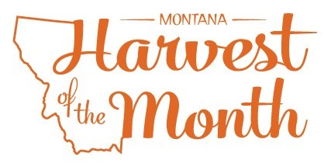MT Harvest of the Month logo
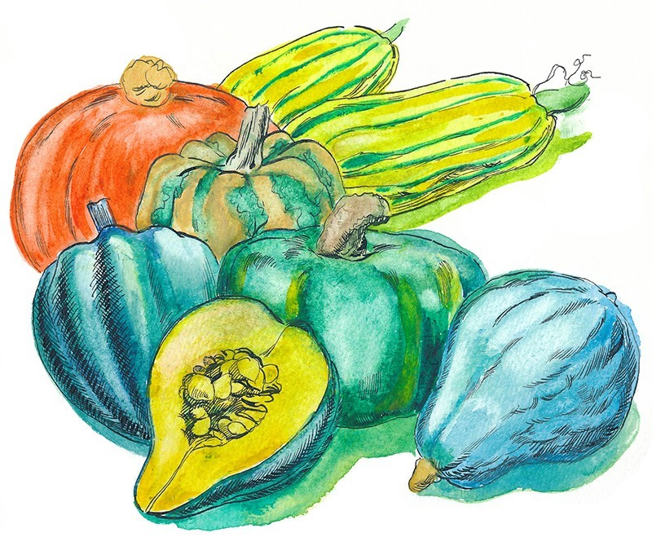

*Updated May 19, 2021*

The Montana Harvest of the Month program showcases Montana grown foods in Montana communities. This program is a collaboration between Montana Farm to School, Office of Public Instruction, Montana Team Nutrition Program, National Center for Appropriate Technology, Montana State University Extension, Gallatin Valley Farm to School, FoodCorps Montana, and Montana Department of Agriculture. More information and resources are available at: [https://mtharvestofthemonth.org.](https://mtharvestofthemonth.org/)

Funds were provided in part by USDA Team Nutrition Training grants, USDA funds, USDA Farm to School grants, Montana Healthcare Foundation, Northern Pulse Growers Association, Montana Department of Public Health and Human Services, Montana School Nutrition Association, Montana Department of Agriculture Specialty Crop Block Grant, Montana Grains Foundation, Dairy MAX, Montana Pulse Crop Committee, Montana Wheat and Barley Committee. This institution is an equal opportunity provider and employer. The Montana State University Extension Service is an ADA/EO/AA/Veteran’s Preference Employer and Provider of Educational Outreach.



The Montana Harvest of the Month program showcases Montana grown foods in Montana communities. This program is a collaboration between Montana Farm to School, Office of Public Instruction, Montana Team Nutrition Program, National Center for Appropriate Technology, Montana State University Extension, Gallatin Valley Farm to School, FoodCorps Montana, and Montana Department of Agriculture. More information and resources are available at: [www.montana.edu/mtharvestofthemonth](http://www.montana.edu/mtharvestofthemonth/).

Funds were provided in part by USDA Team Nutrition Training grants, Northern Pulse Growers Association, Montana Department of Public Health and Human Services, Montana Pulse Crop Committee, Montana Specialty Crop Block Grant Program.  USDA is an equal opportunity provider. The Montana State University Extension Service is an ADA/EO/AA/Veteran’s Preference Employer and Provider of Educational Outreach. This publication was supported by the Grants or Cooperative Agreements Numbers, 6 U58DP004818-03-01 & 5 U58DP004818-03-00, and funded by the Centers for Disease Control and Prevention. Its contents are solely the responsibility of the authors and do not necessarily represent the official views of the Centers for Disease Control and Prevention or the DPHHS.