**Montana Harvest of the Month logo**

Newsletter + Social Media Content

Summer Squash

Instructions

Please adapt and use the verbiage, logos, and images included below for your newsletter, staff announcements, menus, social media posts, etc. To use the verbiage below, please copy and paste the desired language into your document or social media platform. Be sure to add your site-specific information in the sections with {brackets}. The Montana Harvest of the Month logos and illustrations are included for your use as well. For more information, additional guides and resources, or to download logos and illustrations visit [https://mtharvestofthemonth.org.](https://mtharvestofthemonth.org/) Registered sites can download all materials on the Harvest of the Month Online Portal.

Announcement/Newsletter Verbiage

**{MONTH} Harvest of the Month: Summer Squash**

Squash have been a part of our agricultural landscape for a long time! Most squash varieties were first grown and developed in America and were later brought to Europe. However, zucchini originated in Italy. Botanically speaking, squash are the immature fruit of the plant, and you will notice the seeds are inside. Summer squash are a good source of vitamin C, and contains manganese, potassium, and vitamin B6. Manganese is critical in the formation of bone and to keep your skeleton healthy! Try eating summer squash raw or cooked in pasta salads, baked into zucchini chips, or cut into sticks or rounds to eat with your favorite dip.

Summer squash are a great addition to any garden. Zucchini plants grow very well and with any luck you will have enough squash to share with your neighbors. Summer squash need full sun and plenty of room to grow. Some varieties can be successfully grown in containers or trained to grow up a trellis to take up less space in small gardens.

This month, {INSERT TYPE OF SUMMER SQUASH/ZUCCHINI} from {INSERT TOWN OR FARM HERE IF MONTANA/LOCALLY GROWN} will be featured for {INSERT MEAL} on {INSERT DAY}! Students can vote if they “Tried it, Liked it, or Loved it” after trying the Harvest of the Month item in the {INSERT LOCATION OF VOTING, *remove this section if you are not conducting a voting or a taste-test*}*.*

Social Media Posts

**Suggestions for Social Media Posts: Summer Squash *(Red means Twitter Friendly)***

Celebrate the beginning of the school year with August’s #MTHarvestoftheMonth -- summer squash! Versatile in the kitchen, summer squash can be grilled, steamed, or eaten raw in a variety of dishes. Check out the Harvest at Home handout for fun summer squash cooking tips and recipes. <http://bit.ly/mthomsumsquash>

Did you know that summer squash, while not a significant part of Montana agriculture, are widely grown in gardens throughout the state? Learn how to harvest your own and make some yummy summer squash dishes using the Harvest at Home handout. <http://bit.ly/mthomsumsquash>

How many varieties of summer squash can you name? Check out #MTHarvestoftheMonth for that and more! <http://bit.ly/mthomsumsquash>

Celebrate the August #MTHarvestoftheMonth, summer squash, with these delicious baked zucchini chips! <http://bit.ly/mthomsumsquash>

Logos and Illustrations

The logos and illustrations included below are also available for registered sites to download on the Harvest of the Month Online Portal. To use the images from this document, copy and paste the images from this document to your document.

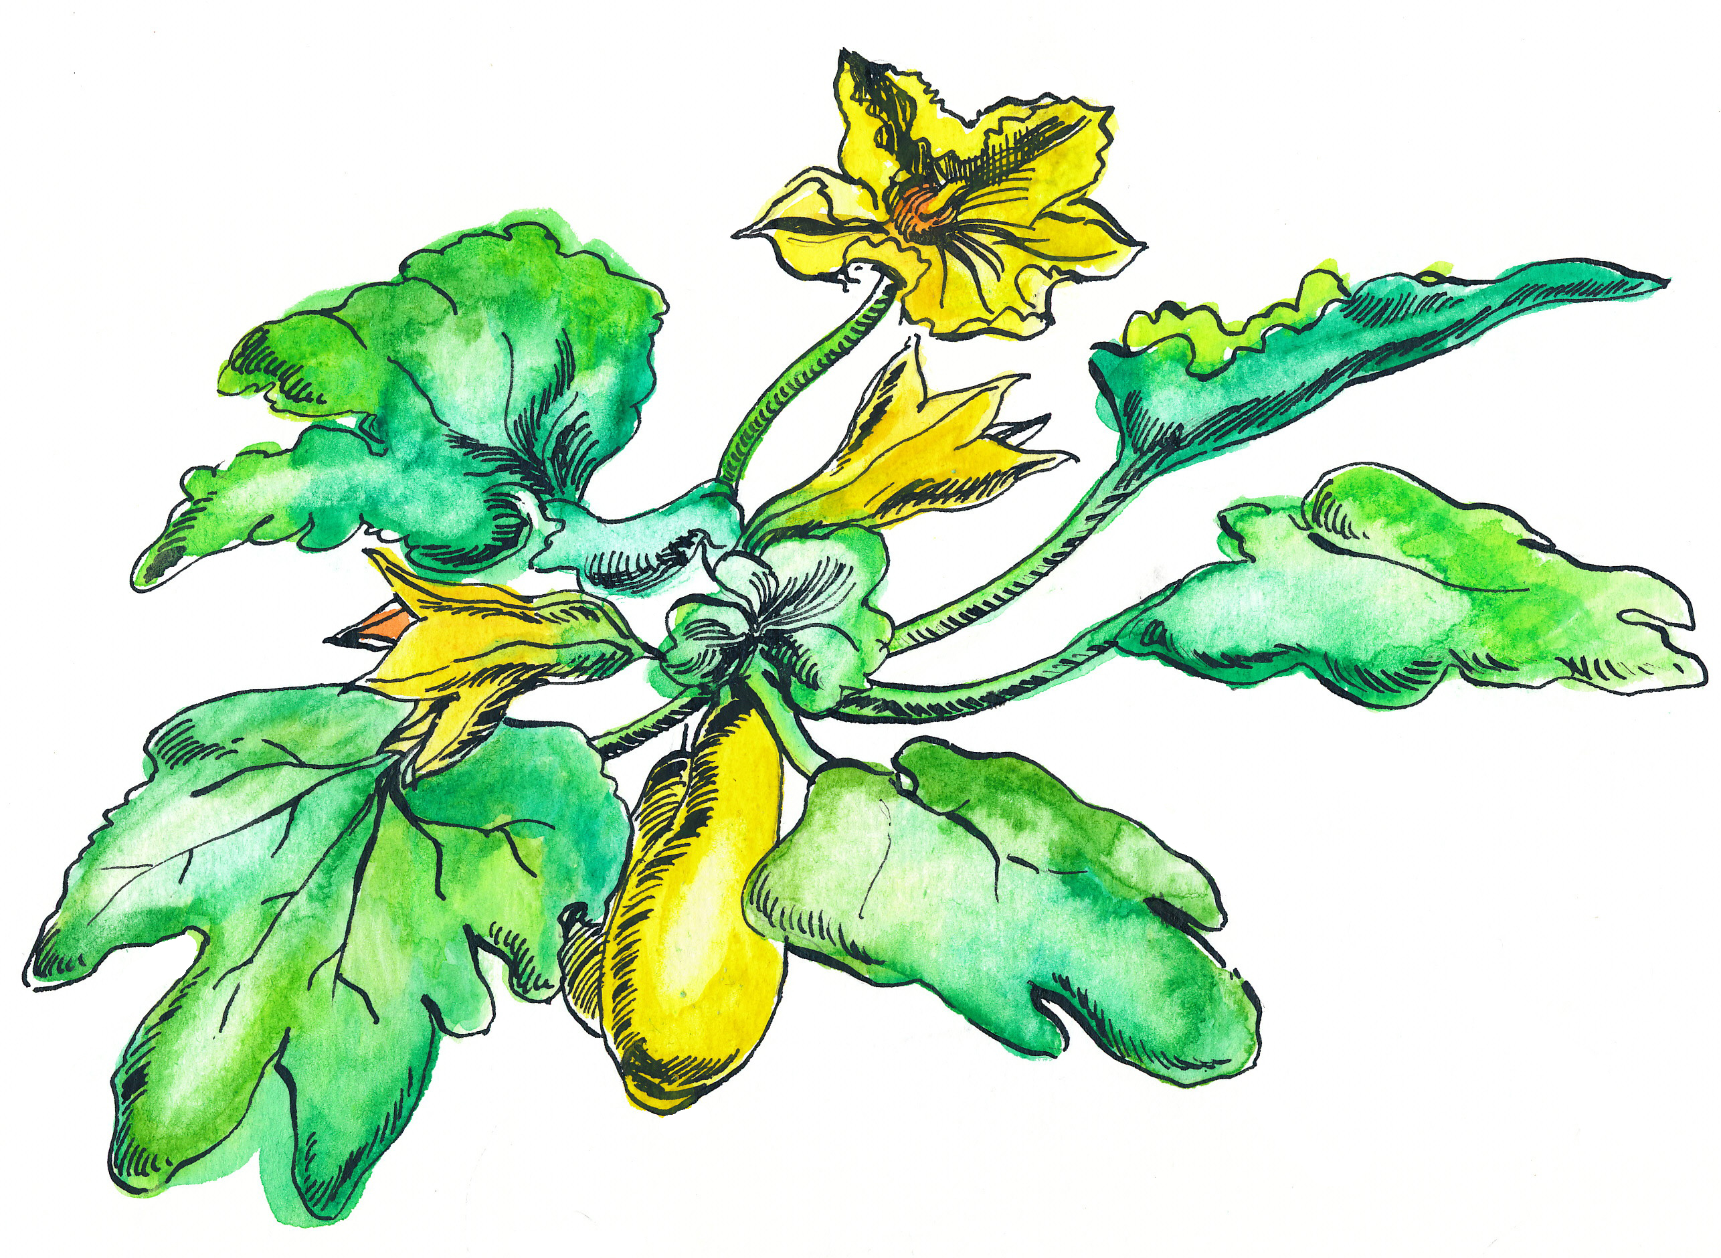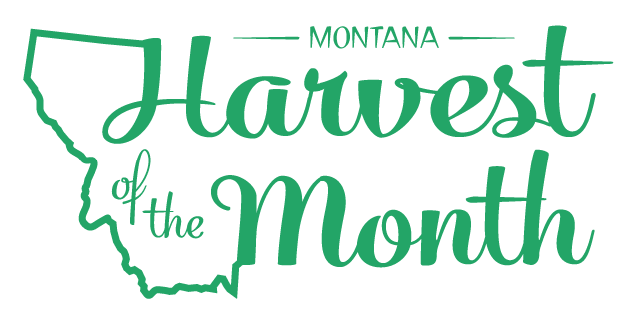

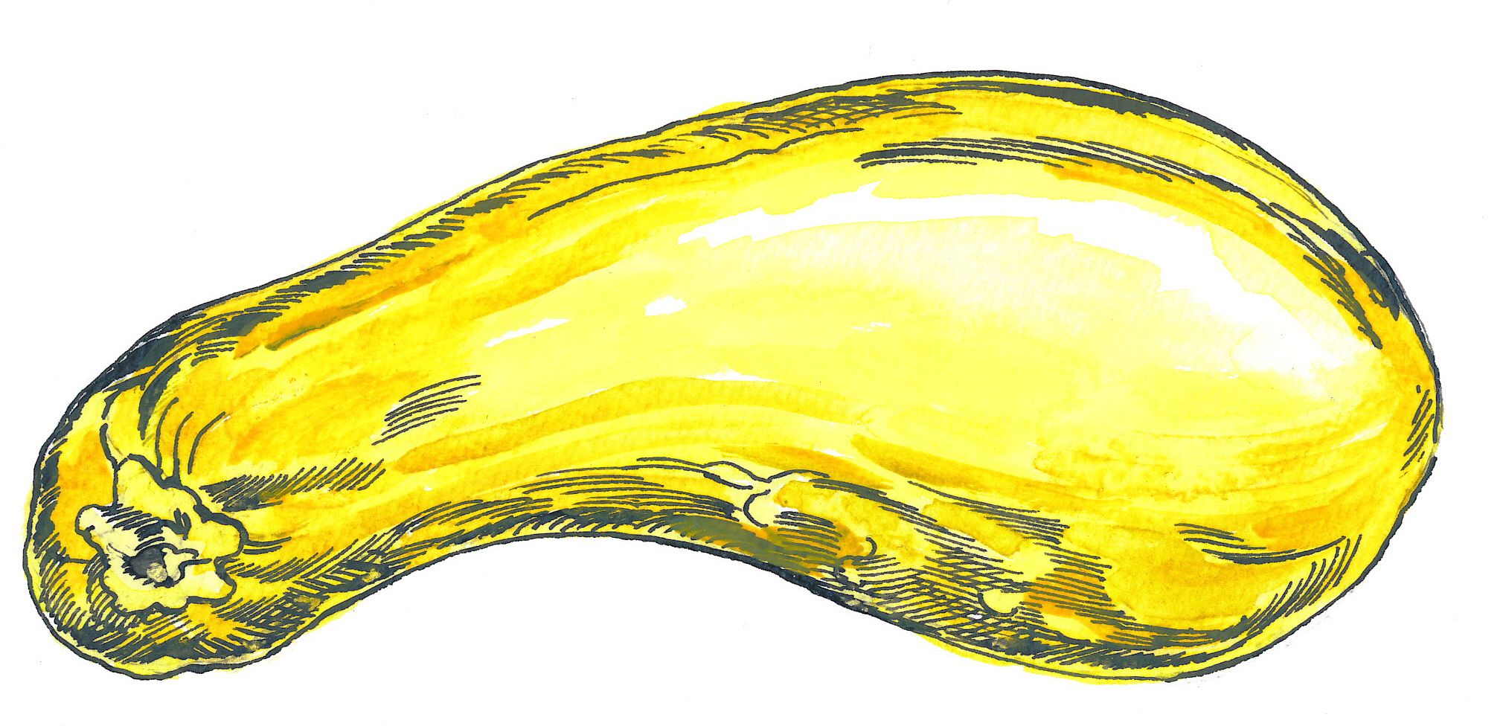

*Updated May 19, 2021*

The Montana Harvest of the Month program showcases Montana grown foods in Montana communities. This program is a collaboration between Montana Farm to School, Office of Public Instruction, Montana Team Nutrition Program, National Center for Appropriate Technology, Montana State University Extension, Gallatin Valley Farm to School, FoodCorps Montana, and Montana Department of Agriculture. More information and resources are available at: [https://mtharvestofthemonth.org.](https://mtharvestofthemonth.org/)

Funds were provided in part by USDA Team Nutrition Training grants, USDA funds, USDA Farm to School grants, Montana Healthcare Foundation, Northern Pulse Growers Association, Montana Department of Public Health and Human Services, Montana School Nutrition Association, Montana Department of Agriculture Specialty Crop Block Grant, Montana Grains Foundation, Dairy MAX, Montana Pulse Crop Committee, Montana Wheat and Barley Committee. This institution is an equal opportunity provider and employer. The Montana State University Extension Service is an ADA/EO/AA/Veteran’s Preference Employer and Provider of Educational Outreach.



The Montana Harvest of the Month program showcases Montana grown foods in Montana communities. This program is a collaboration between Montana Farm to School, Office of Public Instruction, Montana Team Nutrition Program, National Center for Appropriate Technology, Montana State University Extension, Gallatin Valley Farm to School, FoodCorps Montana, and Montana Department of Agriculture. More information and resources are available at: [www.montana.edu/mtharvestofthemonth](http://www.montana.edu/mtharvestofthemonth/).

Funds were provided in part by USDA Team Nutrition Training grants, Northern Pulse Growers Association, Montana Department of Public Health and Human Services, Montana Pulse Crop Committee, Montana Specialty Crop Block Grant Program.  USDA is an equal opportunity provider. The Montana State University Extension Service is an ADA/EO/AA/Veteran’s Preference Employer and Provider of Educational Outreach. This publication was supported by the Grants or Cooperative Agreements Numbers, 6 U58DP004818-03-01 & 5 U58DP004818-03-00, and funded by the Centers for Disease Control and Prevention. Its contents are solely the responsibility of the authors and do not necessarily represent the official views of the Centers for Disease Control and Prevention or the DPHHS.