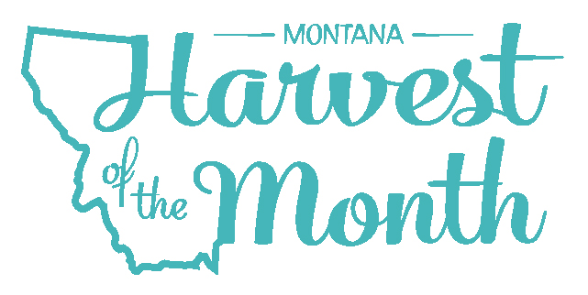
September 2021
Your School Name/Logo

Monday | Tuesday | Wednesday | Thursday | Friday
 |  | 1  Write Here | 2  Write Here | 3  Write Here
6  Write Here | 7  Write Here | 8  Write Here | 9  Write Here | 10  Write Here
13  Write Here | 14  Write Here | 15  Write Here | 16  Write Here | 17  Write Here
20  Write Here | 21  Write Here | 22  Write Here | 23  Write Here | 24  Write Here
27  Write Here | 28  Write Here | 29  Write Here | 30  Write Here

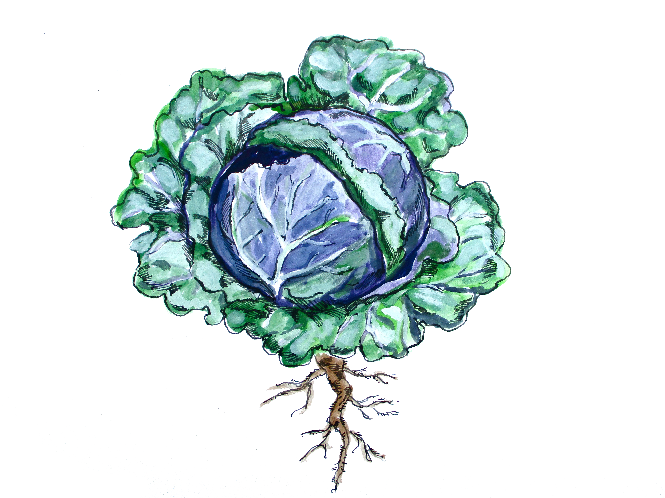
Brassicas are this month’s Harvest of the Month. Did you know…
- Brassicas are in the vegetable food group.
- “Brassica” is a genus, or group of closely related plants, in the mustard family. There are 3700+ species in the Brassica plant family, ranging from cabbage to kohlrabi.
- Although the Brassica genus is extremely diverse, most Brassicas are excellent sources of vitamin C and good sources of potassium, vitamin A, and vitamin B6.
To learn more about Montana Harvest of the Month visit:
https://mtharvestofthemonth.org/

