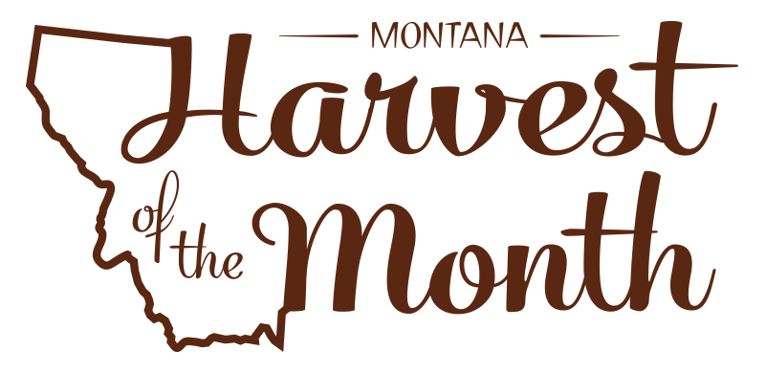

Your School Name/Logo
May 2022

Monday | Tuesday | Wednesday | Thursday | Friday
2  Write Here | 3  Write Here | 4  Write Here | 5  Write Here | 6  Write Here
9  Write Here | 10  Write Here | 11  Write Here | 12  Write Here | 13  Write Here
16  Write Here | 17  Write Here | 18  Write Here | 19  Write Here | 20  Write Here
23  Write Here | 24  Write Here | 25  Write Here | 26  Write Here | 27  Write Here
30  Write Here | 31  Write Here
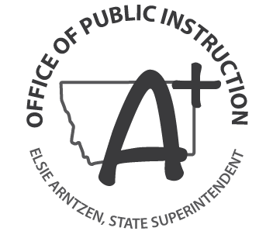
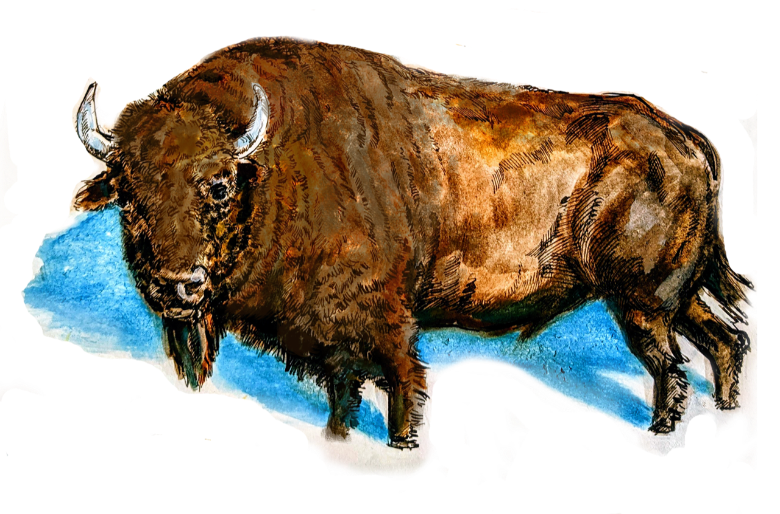
Bison is this month’s Harvest of the Month. Did you know…
- Bison are the largest land mammals in North America.
- Bison have been a critical species to tribes in Montana and the region for thousands of years, providing them with food, tools, shelter, clothing, fuel, and spiritual value.
- Bison can run up to 35 miles per hour.
- In 2014, the Buffalo Treaty was signed between 13 different Indigenous nations in Canada and the U.S. This treaty recognizes these nations as safe places for bison.
To learn more about Montana Harvest of the Month visit:
mtharvestofthemonth.org

