**Montana Harvest of the Month logo**

Newsletter + Social Media Content

Leafy Greens

Instructions

Please adapt and use the verbiage, logos, and images included below for your newsletter, staff announcements, menus, social media posts, etc. To use the verbiage below, please copy and paste the desired language into your document or social media platform. Be sure to add your site-specific information in the sections with {brackets}. The Montana Harvest of the Month logos and illustrations are included for your use as well. For more information, additional guides and resources, or to download logos and illustrations visit [https://mtharvestofthemonth.org.](https://mtharvestofthemonth.org/) Registered sites can download all materials on the Harvest of the Month Online Portal.

Announcement/Newsletter Verbiage

**June Harvest of the Month: Leafy Greens**

Leafy greens, including lettuce, chard, bok choy, spinach, and collards are easy to grow and easy to eat. It’s no wonder that the average American eats about 30 pounds of lettuce every year! These greens are tasty when eaten both raw or cooked. Make a “Green Monster Smoothie” by adding fresh spinach or chard to your favorite smoothie and turning it green! Most greens are good sources of folate, vitamin A, vitamin C, calcium, and potassium. Many greens also provide vitamin K, which helps the body stop cuts and scrapes from bleeding too much and starts the healing process.

Although greens are not a large part of Montana’s agricultural economy, they are perfect for gardens as they are frost tolerant and easy to grow. Fast growing greens like lettuce and spinach are often the first local veggies available in the spring.

This month, {INSERT TYPE OF GREEN} from {INSERT TOWN OR FARM HERE IF MONTANA/LOCALLY GROWN} will be featured for {INSERT MEAL} on {INSERT DAY}! Students can vote if they “Tried it, Liked it, or Loved it” after trying the Harvest of the Month item in the {INSERT LOCATION OF VOTING, *remove this section if you are not conducting a voting or a taste-test*}*.*

Social Media Posts

**Suggestions for Social Media Posts: Leafy Greens** *(Red means Twitter Friendly)*

Lettuce, spinach, collards, and chard are all part of June’s #MTHarvestoftheMonth, leafy greens! These green goodies are perfect for growing in gardens and aren’t just for salads. Read the Harvest at Home handout for other dishes you can add leafy greens to, as well as fun facts and growing tips! <http://bit.ly/mthomleafygreens>

Leafy Greens are June’s #MTHarvestoftheMonth! Try making some yummy green smoothies by simply adding fresh spinach or chard along with your favorite ingredients!

What do lettuce, spinach, and collards all have in common? They are June’s #MTHarvestoftheMonth, leafy greens! <http://bit.ly/mthomleafygreens>

Celebrate summer and June’s #MTHarvestoftheMonth with yummy leafy greens in smoothies and salads. <http://bit.ly/mthomleafygreens>

Logos and Illustrations

The logos and illustrations included below are also available for registered sites to download on the Harvest of the Month Online Portal. To use the images from this document, copy and paste the images from this document to your document.

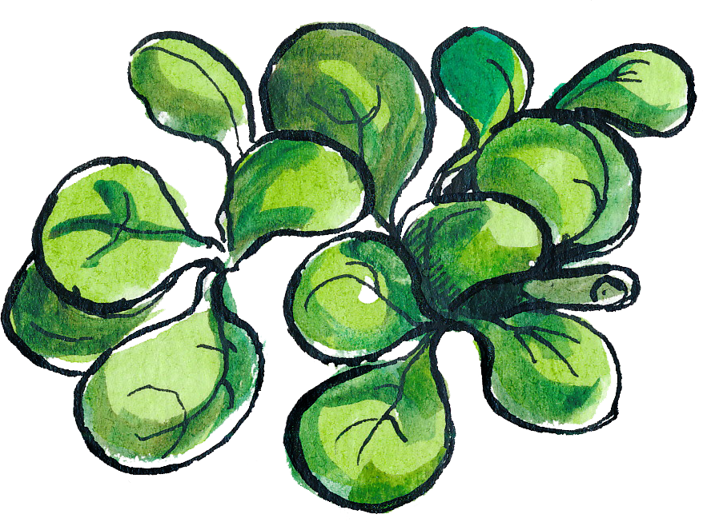 

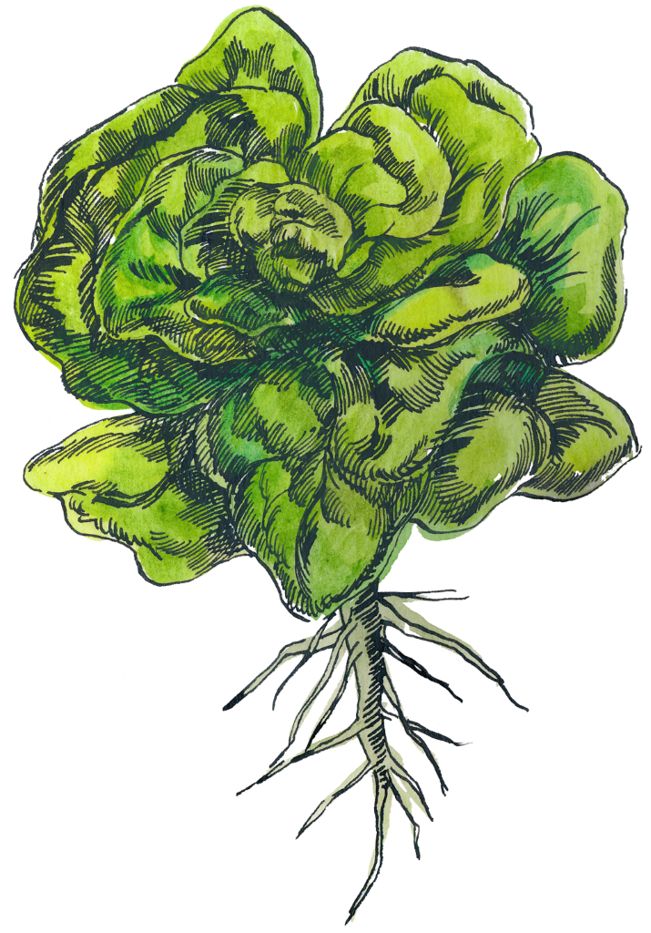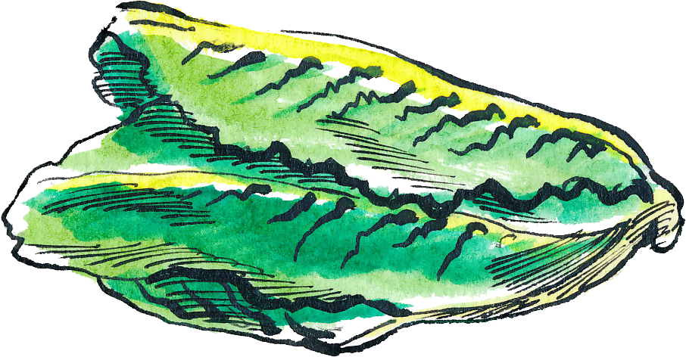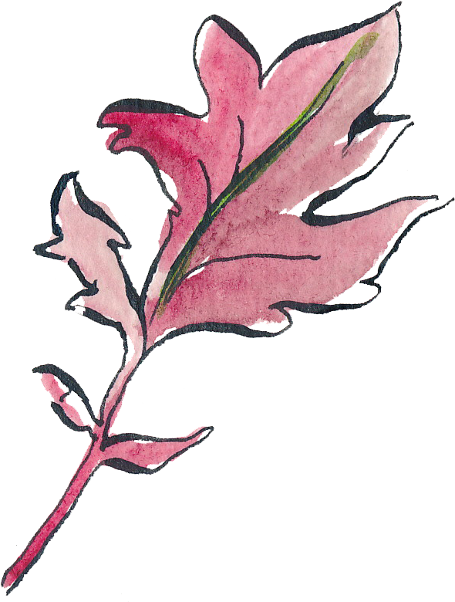

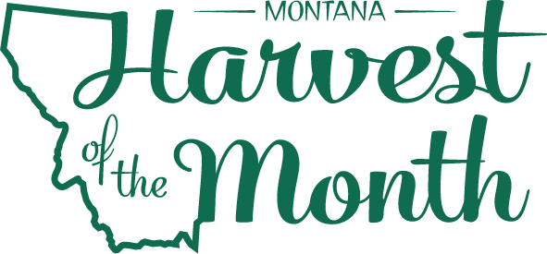

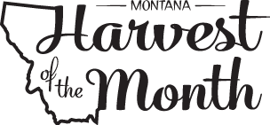

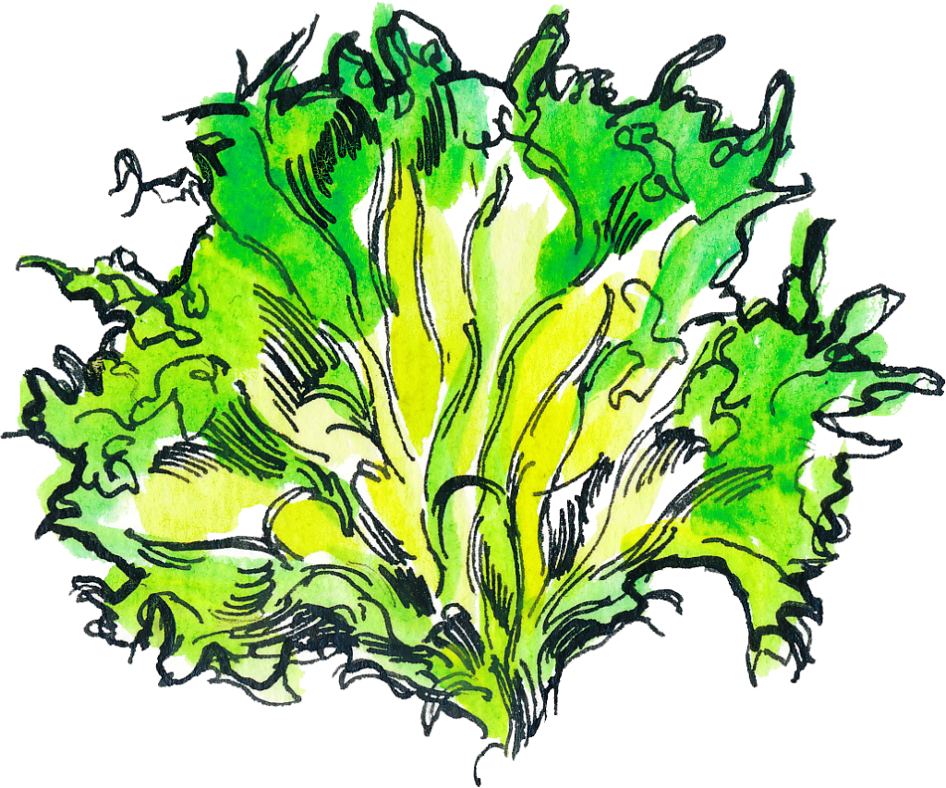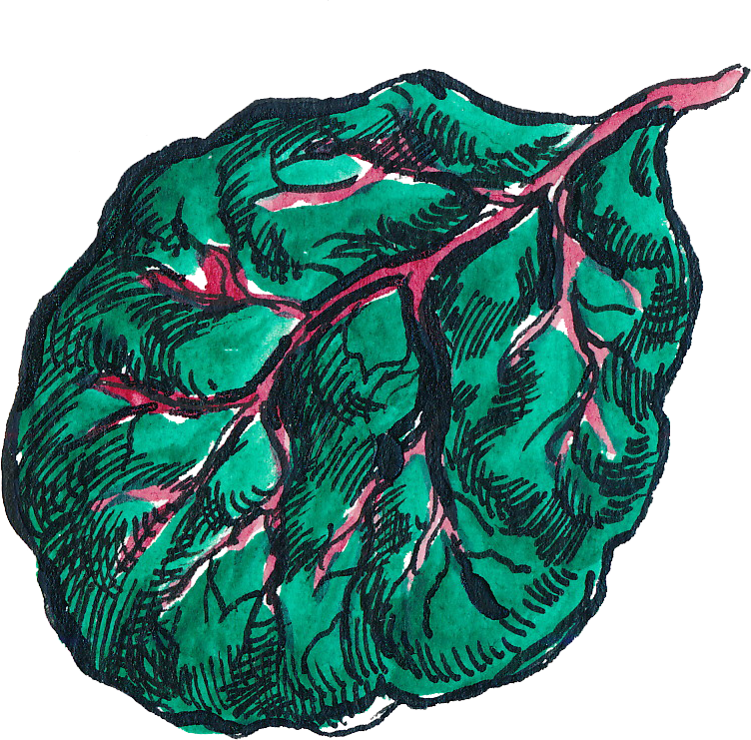

*Updated May 19, 2021*

The Montana Harvest of the Month program showcases Montana grown foods in Montana communities. This program is a collaboration between Montana Farm to School, Office of Public Instruction, Montana Team Nutrition Program, National Center for Appropriate Technology, Montana State University Extension, Gallatin Valley Farm to School, FoodCorps Montana, and Montana Department of Agriculture. More information and resources are available at: [https://mtharvestofthemonth.org.](https://mtharvestofthemonth.org/)

Funds were provided in part by USDA Team Nutrition Training grants, USDA funds, USDA Farm to School grants, Montana Healthcare Foundation, Northern Pulse Growers Association, Montana Department of Public Health and Human Services, Montana School Nutrition Association, Montana Department of Agriculture Specialty Crop Block Grant, Montana Grains Foundation, Dairy MAX, Montana Pulse Crop Committee, Montana Wheat and Barley Committee. This institution is an equal opportunity provider and employer. The Montana State University Extension Service is an ADA/EO/AA/Veteran’s Preference Employer and Provider of Educational Outreach.



The Montana Harvest of the Month program showcases Montana grown foods in Montana communities. This program is a collaboration between Montana Farm to School, Office of Public Instruction, Montana Team Nutrition Program, National Center for Appropriate Technology, Montana State University Extension, Gallatin Valley Farm to School, FoodCorps Montana, and Montana Department of Agriculture. More information and resources are available at: [www.montana.edu/mtharvestofthemonth](http://www.montana.edu/mtharvestofthemonth).

Funds were provided in part by USDA Team Nutrition Training grants, Northern Pulse Growers Association, Montana Department of Public Health and Human Services, Montana Pulse Crop Committee, Montana Specialty Crop Block Grant Program.  USDA is an equal opportunity provider. The Montana State University Extension Service is an ADA/EO/AA/Veteran’s Preference Employer and Provider of Educational Outreach. This publication was supported by the Grants or Cooperative Agreements Numbers, 6 U58DP004818-03-01 & 5 U58DP004818-03-00, and funded by the Centers for Disease Control and Prevention. Its contents are solely the responsibility of the authors and do not necessarily represent the official views of the Centers for Disease Control and Prevention or the DPHHS.