**Montana Harvest of the Month logo**

Newsletter + Social Media Content

Apples

Instructions

Please adapt and use the verbiage, logos, and images included below for your newsletter, staff announcements, menus, social media posts, etc. To use the verbiage below, please copy and paste the desired language into your document or social media platform. Be sure to add your site-specific information in the sections with {brackets}. The Montana Harvest of the Month logos and illustrations are included for your use as well. For more information, additional guides and resources, or to download logos and illustrations visit [https://mtharvestofthemonth.org.](https://mtharvestofthemonth.org/) Registered sites can download all materials on the Harvest of the Month Online Portal.

Announcement/Newsletter Verbiage

**October Harvest of the Month: Apples**

The old saying “an apple a day keeps the doctor away” certainly holds some truth! Apples are an excellent part of a healthy diet by providing fiber, vitamin C, potassium, and other nutrients. Potassium is an electrolyte that is essential to keep your heart beating! Bite into a Montana apple today!

Apple trees are a long-term investment. They can take multiple years to produce fruit after planting. However, they can live up to 100 years old, providing delicious lunchbox treats for generations. There are over 7,500 varieties of apples grown worldwide and 2,500 are grown in the US. However, only a handful of varieties are commonly found in grocery stores today.

This month, {INSERT TYPE OF APPLE} from {INSERT TOWN OR FARM HERE IF MONTANA/LOCALLY GROWN} will be featured for {INSERT MEAL} on {INSERT DAY}! Students can vote if they “Tried it, Liked it, or Loved it” after trying the Harvest of the Month item in the {INSERT LOCATION OF VOTING, *remove this section if you are not conducting a voting or a taste-test*}*.*

Social Media Posts

**Suggestions for Social Media Posts: Apples** *(Red means Twitter Friendly)*

Apples are October’s #MTHarvestoftheMonth. A good source of nutrients like fiber, vitamin C, and potassium, apples were brought to the United States all the way back in the 17th century! Read the Harvest at Home handout for fun facts, buying tips, and yummy apple recipes. <http://bit.ly/mthomapples>

Bite into a Montana apple this October! #MTHarvestoftheMonth’s Harvest at Home handout explores creative ways to cook and eat this autumn staple. <http://bit.ly/mthomapples>

This October, keep the doctor away by eating an apple a day! #MTHarvestoftheMonth

Do you know how to choose the best apples? Learn apple fun facts, buying tips, and more from #MTHarvestoftheMonth: <http://bit.ly/mthomapples>

Logos and Illustrations

The logos and illustrations included below are also available for registered sites to download on the Harvest of the Month Online Portal. To use the images from this document, copy and paste the images from this document to your document.

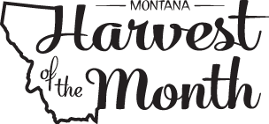

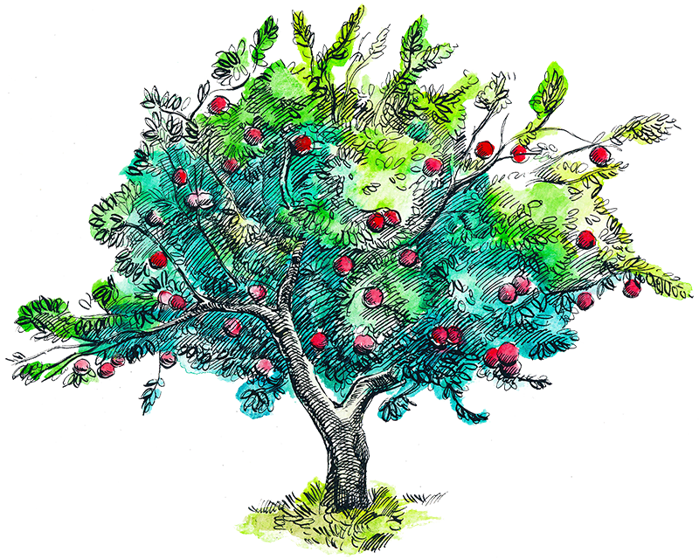

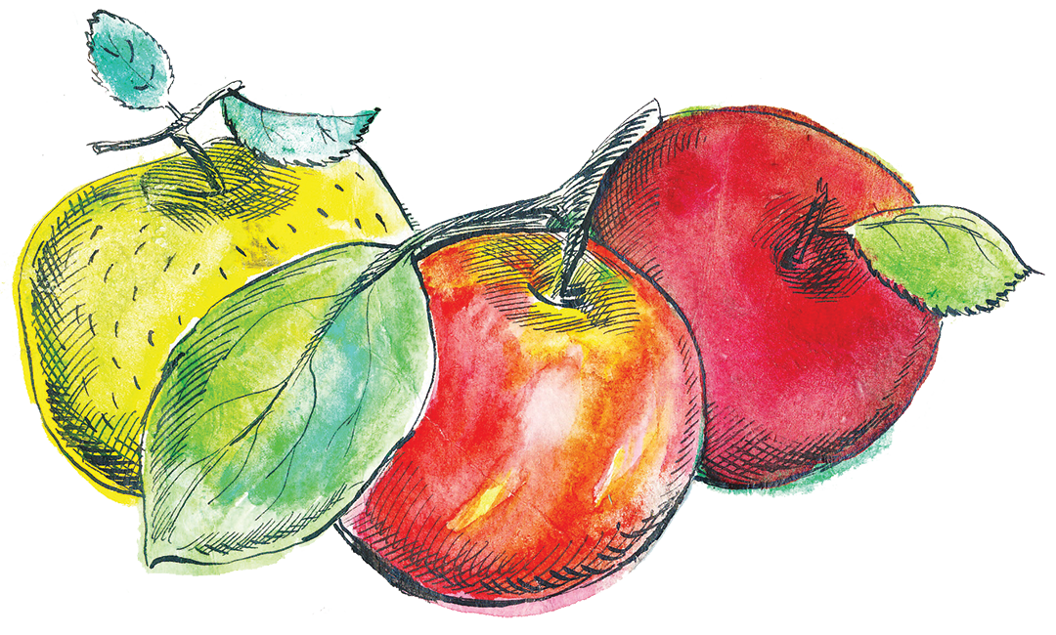

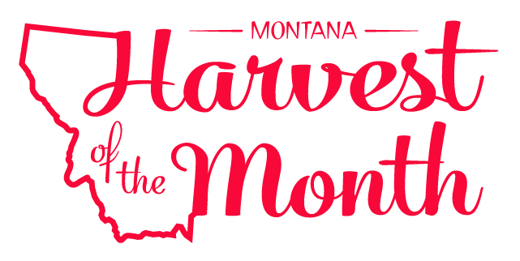

The Montana Harvest of the Month program showcases Montana grown foods in Montana communities. This program is a collaboration between Montana Farm to School, Office of Public Instruction, Montana Team Nutrition Program, National Center for Appropriate Technology, Montana State University Extension, Gallatin Valley Farm to School, FoodCorps Montana, and Montana Department of Agriculture. More information and resources are available at: [https://mtharvestofthemonth.org.](https://mtharvestofthemonth.org/)

Funds were provided in part by USDA Team Nutrition Training grants, USDA funds, USDA Farm to School grants, Montana Healthcare Foundation, Northern Pulse Growers Association, Montana Department of Public Health and Human Services, Montana School Nutrition Association, Montana Department of Agriculture Specialty Crop Block Grant, Montana Grains Foundation, Dairy MAX, Montana Pulse Crop Committee, Montana Wheat and Barley Committee. This institution is an equal opportunity provider and employer. The Montana State University Extension Service is an ADA/EO/AA/Veteran’s Preference Employer and Provider of Educational Outreach.



The Montana Harvest of the Month program showcases Montana grown foods in Montana communities. This program is a collaboration between Montana Farm to School, Office of Public Instruction, Montana Team Nutrition Program, National Center for Appropriate Technology, Montana State University Extension, Gallatin Valley Farm to School, FoodCorps Montana, and Montana Department of Agriculture. More information and resources are available at: [www.montana.edu/mtharvestofthemonth](http://www.montana.edu/mtharvestofthemonth/).

Funds were provided in part by USDA Team Nutrition Training grants, Northern Pulse Growers Association, Montana Department of Public Health and Human Services, Montana Pulse Crop Committee, Montana Specialty Crop Block Grant Program.  USDA is an equal opportunity provider. The Montana State University Extension Service is an ADA/EO/AA/Veteran’s Preference Employer and Provider of Educational Outreach. This publication was supported by the Grants or Cooperative Agreements Numbers, 6 U58DP004818-03-01 & 5 U58DP004818-03-00, and funded by the Centers for Disease Control and Prevention. Its contents are solely the responsibility of the authors and do not necessarily represent the official views of the Centers for Disease Control and Prevention or the DPHHS.

*Updated May 19, 2021*