**Macintosh HD:Users:F2SCoordinator:Documents:MT Team Nutrition:Grants:TN Grants:2014 - 16:2.1 Harvest of the Month:HOM Launch:HOM Launch Packaged Files:Apples:MTHOM_Apples_Cafeteria:Links:MTHOM_LOGO-apples.eps**

Summer Squash | Explore Summer Squash

Activities

Developed by: Gallatin Valley Farm to School ([www.gvfarmtoschool.org)](http://www.gvfarmtoschool.org))

Grades

Afterschool | K-5

Objectives

Within this lesson, students will be able to discover the wide variety of squashes. Utilizing, measurement, grouping, and classification they will identify similarities and difference within varieties. Students will then taste fresh, local squash!

Students will be able to:

* Compare different varieties of summer squash using observations, scientific diagrams, and descriptions
* Discuss the differences between winter squash and summer squash
* Taste summer squash

Materials

Dig Deeper

Get more information, register, or download resources:

Aubree Roth

Montana Farm to School Coordinator

aubree.roth@montana.edu | (406) 994-5996 [mtharvestofthemonth.org](http://mtharvestofthemonth.org/)

* 2 squash per small group of students. Use multiple varieties of summer squash, including: yellow crookneck, yellow straight neck, zucchini, patty pan/scallop.
* Paper bag(s)
* White board
* Science notebook or paper and pencil for each student
* 1 butter knife per group

Directions

* Place a summer squash in a paper bag, or a few different varieties in different bags. Begin by passing around the “mystery bag” (paper bag with the summer squash in it) and ask students to feel the item without looking. Once all students have felt the item, ask for students to use descriptive words to explain what they felt inside the bag without giving it away to the group. Students may also make predictions for qualities of the item they could not feel, such as color, is it a food, etc. Write these words on the board.
* Ask a few students to share what they think the item is and why, but do not confirm nor deny their guess. Tell students that you will now unveil the mystery item(s). Slowly take the squash out of the bag and then ask students to raise their hand if they correctly guessed. Were any of the descriptions correct? Were any incorrect? (Did they guess it would be green but really it was yellow? Discuss varieties of squash!)
* Explain that this month’s Harvest of the Month crop is summer squash! Ask students to raise their hand if they’ve ever tried summer squash. Today they will all have the opportunity to taste it!
* Ask if anyone has heard of a different kind of squash (winter squash). Explain that squash is divided into two categories, summer and winter squash, and show students examples of both. Ask students to consider what the differences are between the two (thickness of skin, when and how you eat it, size, storage, etc.).
* Divide students into small groups and pass out two summer squash of different varieties to each group. Give students time to observe and measure the squash using rulers. Next, ask students to create a Venn diagram with their findings to compare the two varieties summer. With younger students it may be best to complete this as a class, while older students may work in groups.
* Once students have completed the observation, hand out one butter knife per group. Review and demonstrate safe knife handling practices, and then have students cut each variety of squash into slices to taste. Alternately, precut the squash. As a class, say “cheers to summer squash” and then taste each variety. Ask students to record the taste and texture differences and similarities on their Venn diagrams on paper or in their science or garden notebooks.
* Once students have completed the taste test, compare and contrast observations and make general comparisons between the varieties.

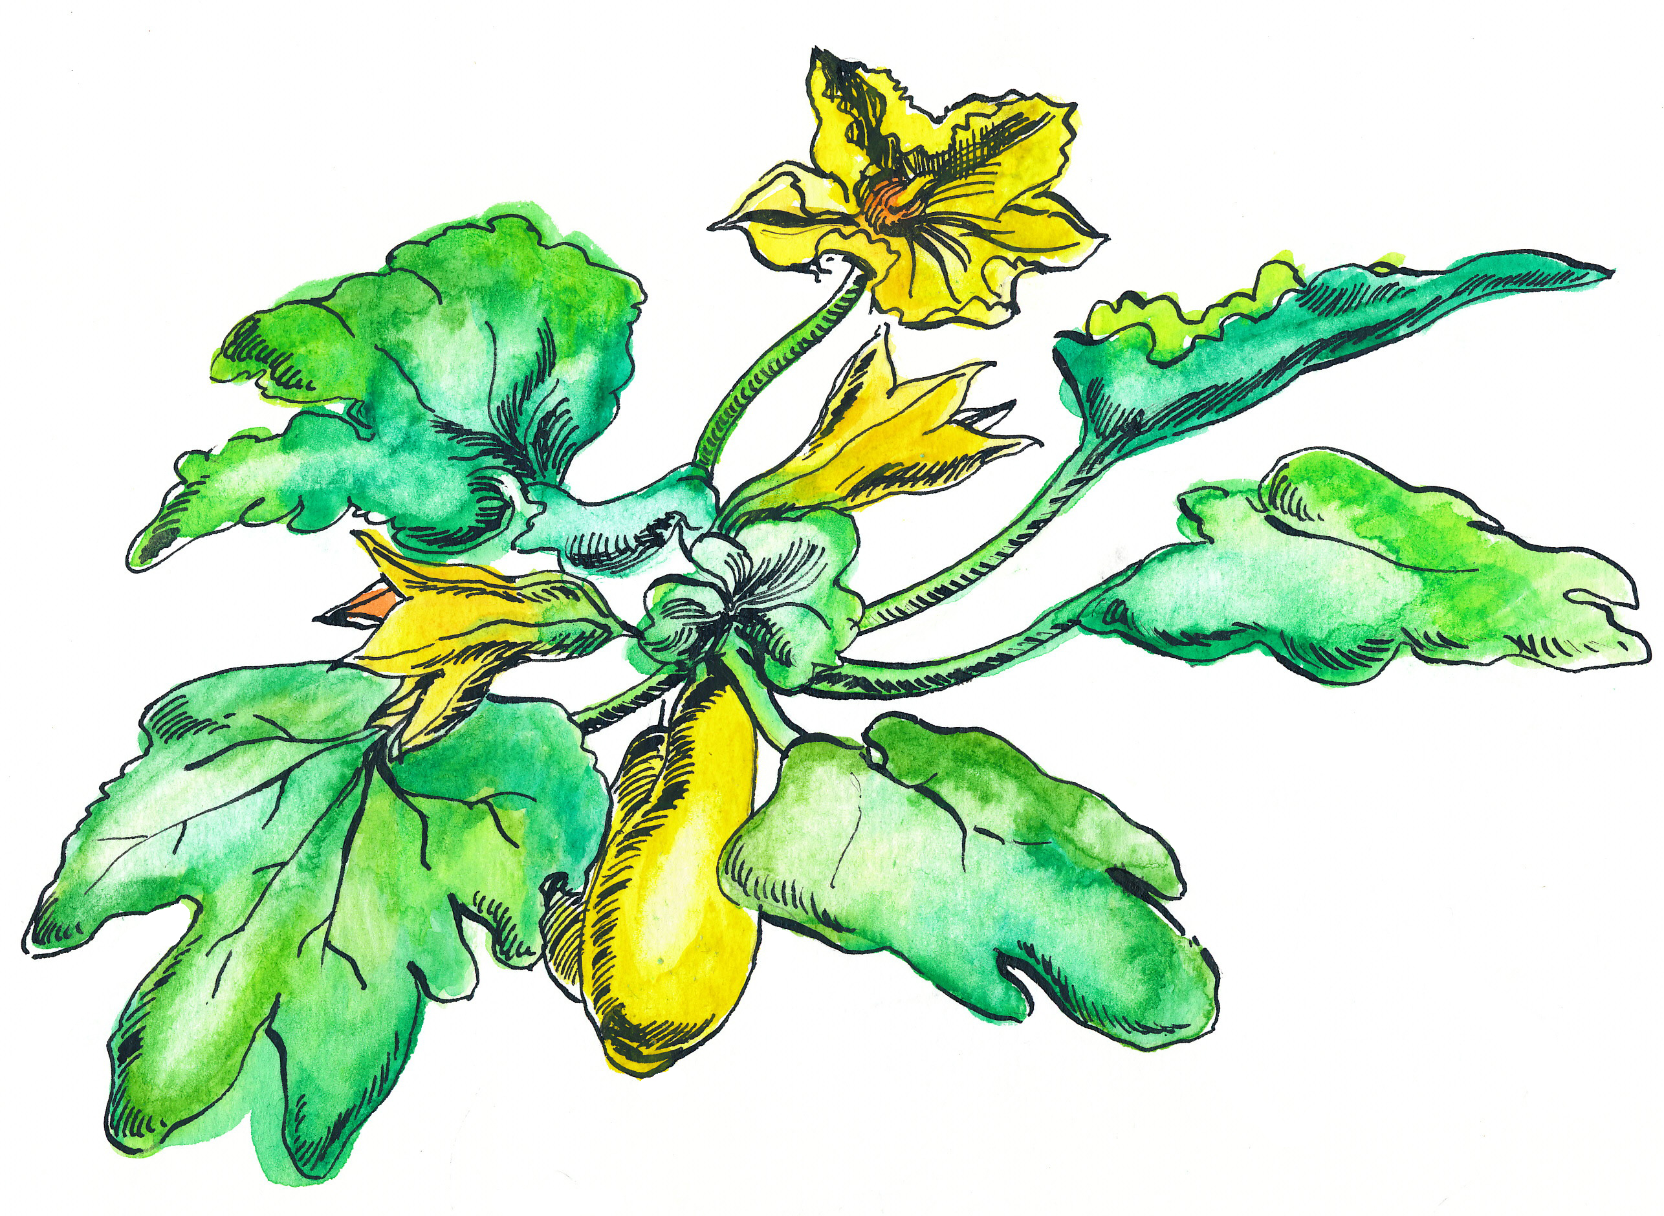

The Montana Harvest of the Month program showcases Montana grown foods in Montana communities. This program is a collaboration between Montana Farm to School, Office of Public Instruction, Montana Team Nutrition Program, National Center for Appropriate Technology, Montana State University Extension, Gallatin Valley Farm to School, FoodCorps Montana, Montana Organic Association, and Montana Department of Agriculture. More information and resources are available at: [mtharvestofthemonth.org.](https://mtharvestofthemonth.org/)

Funds were provided in part by a USDA Team Nutrition Training grant, a USDA Farm to School grant, Montana Healthcare Foundation, Northern Pulse Growers Association, Montana Department of Public Health and Human Services, and Montana School Nutrition Association.  USDA is an equal opportunity provider and employer. The Montana State University Extension Service is an ADA/EO/AA/Veteran’s Preference Employer and Provider of Educational Outreach. This publication was supported by the Grants or Cooperative Agreements Numbers, 6 U58DP004818-03-01 & 5 U58DP004818-03-00, and funded by the Centers for Disease Control and Prevention. Its contents are solely the responsibility of the authors and do not necessarily represent the official views of the Centers for Disease Control and Prevention or the DPHHS.

