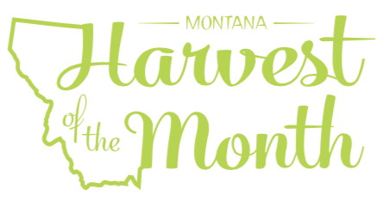
April 2022
Your School Name/Logo

Monday | Tuesday | Wednesday | Thursday | Friday
1
Write Here
4  Write Here | 5  Write Here | 6  Write Here | 7  Write Here | 8  Write Here
11  Write Here | 12  Write Here | 13  Write Here | 14  Write Here | 15  Write Here
18  Write Here | 19  Write Here | 20  Write Here | 21  Write Here | 22  Write Here
25  Write Here | 26  Write Here | 27  Write Here | 28  Write Here | 29  Write Here
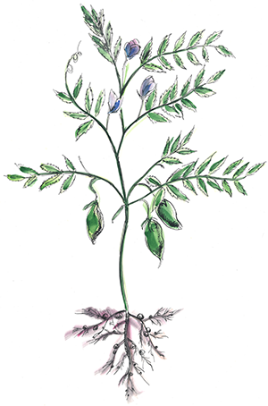
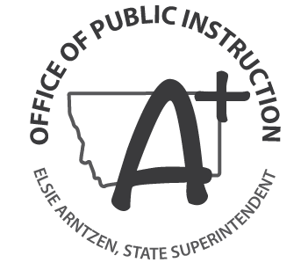
Chickpeas are this month’s Harvest of the Month. Did you know…
- Chickpeas, also called garbanzo beans, have been enjoyed as a nutritious food source for 7,000 years. The name chickpea comes from their similarity of appearance to a chick’s beak.
- Chickpeas are a nutrient powerhouse. They are an excellent source of many nutrients including potassium, calcium, iron, vitamin B-6, and magnesium.
- Montana’s production of chickpeas is growing. In 2016, Montana farmers harvested 254,000 acres of chickpeas.
To learn more about Montana Harvest of the Month visit: https://mtharvestofthemonth.org/

