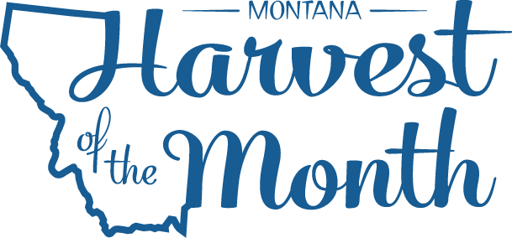
May 2022
Your School Name/Logo

Monday | Tuesday | Wednesday | Thursday | Friday
2  Write Here | 3  Write Here | 4  Write Here | 5  Write Here | 6  Write Here
9  Write Here | 10  Write Here | 11  Write Here | 12  Write Here | 13  Write Here
16  Write Here | 17  Write Here | 18  Write Here | 19  Write Here | 20  Write Here
23  Write Here | 24  Write Here | 25  Write Here | 26  Write Here | 27  Write Here
30  Write Here | 31  Write Here
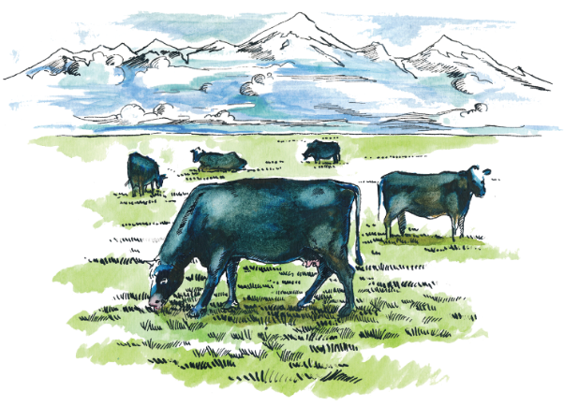
Beef is this month’s Harvest of the Month. Did you know…
- Montana is home to more cattle than people and ranks 6th in the nation for the number of beef cattle.
- The first beef cattle arrived in the United States via Mexico in the 1500s, but more arrived in the early 1600s. In Virginia in 1620 about 500 cows roamed the fields, and less than a decade later the population increased to 30,000 bovines!
- Beef is an excellent source of vitamin B12 and protein and a good source of iron and vitamin B6. Protein helps build and repair body tissues including muscles.

To learn more about Montana Harvest of the Month visit:
https://mtharvestofthemonth.org/

