**Montana Harvest of the Month logo**

Newsletter + Social Media Content

Grains

Instructions

Please adapt and use the verbiage, logos, and images included below for your newsletter, staff announcements, menus, social media posts, etc. To use the verbiage below, please copy and paste the desired language into your document or social media platform. Be sure to add your site-specific information in the sections with {brackets}. The Montana Harvest of the Month logos and illustrations are included for your use as well. For more information, additional guides and resources, or to download logos and illustrations visit [https://mtharvestofthemonth.org.](https://mtharvestofthemonth.org/) Registered sites can download all materials on the Harvest of the Month Online Portal.

Announcement/Newsletter Verbiage

**March Harvest of the Month: Grains**

Many grains and cereal crops are grown in Montana’s fields such as wheat, barley, corn, etc. All these grains are very important for our economy. In 2013, wheat production was valued over $1.3 billion, which includes 203,070,000 bushels, making Montana the 3rd top producer of wheat in the country!

The process of refining grains to make flour and other products removes the fiber and some of the nutrients, such as B vitamins, from the grain. These nutrients, especially fiber, are vital for a healthy digestive system. Therefore, select at least half of your grains from whole grain sources. Whole grain sources include whole wheat bread, oatmeal, whole corn, and hulled barley. See how many different types of grains you can try this month! From purple barley to Kamut wheat to red corn, there are many interesting options to keep your grains varied.

This month, {INSERT TYPE OF GRAIN} from {INSERT TOWN OR FARM HERE IF MONTANA/LOCALLY GROWN} will be featured for {INSERT MEAL} on {INSERT DAY}! Students can vote if they “Tried it, Liked it, or Loved it” after trying the Harvest of the Month item in the {INSERT LOCATION OF VOTING, *remove this section if you are not conducting a voting or a taste-test*}*.*

Social Media Posts

**Suggestions for Social Media Posts: Grains** *(Red means Twitter Friendly)*

Montana fields grow many different grains like wheat, barley, oats, and corn. Did you know that wheat production in Montana was valued over $1.3 billion in 2013? Support the local economy by enjoying the Montana-grown grains this month! #MTHarvestoftheMonth <http://bit.ly/mthomgrains>

March’s #MTHarvestoftheMonth is grains! Remember to get at least half of your grains from whole grain sources. Find out why this is important, along with recipe ideas to incorporate whole grains into your meals, on the Harvest at Home handout. <http://bit.ly/mthomgrains>

March’s #MTHarvestoftheMonth is grains. Learn why whole grains are a better choice: <http://bit.ly/mthomgrains>

Logos and Illustrations

The logos and illustrations included below are also available for registered sites to download on the Harvest of the Month Online Portal. To use the images from this document, copy and paste the images from this document to your document.

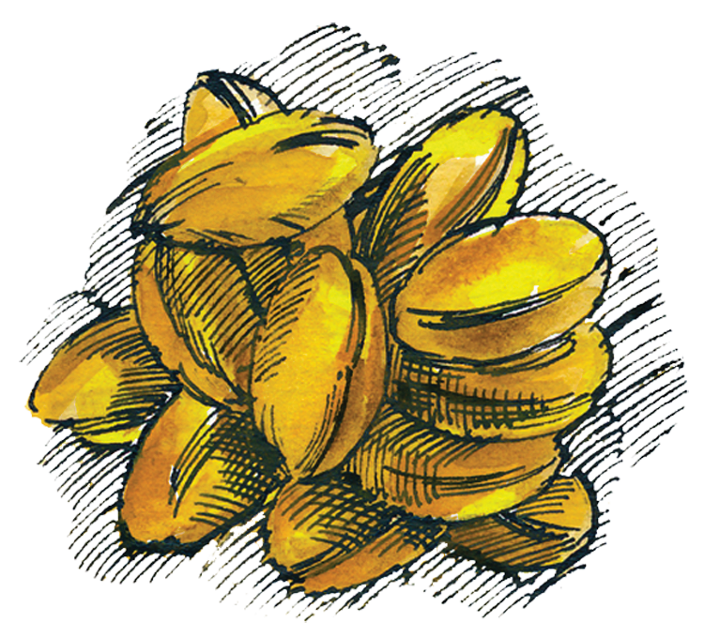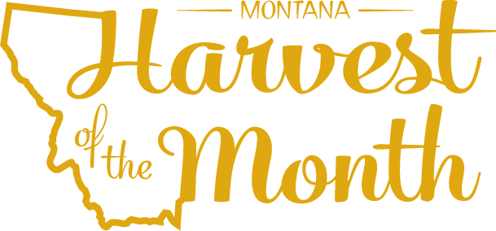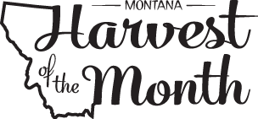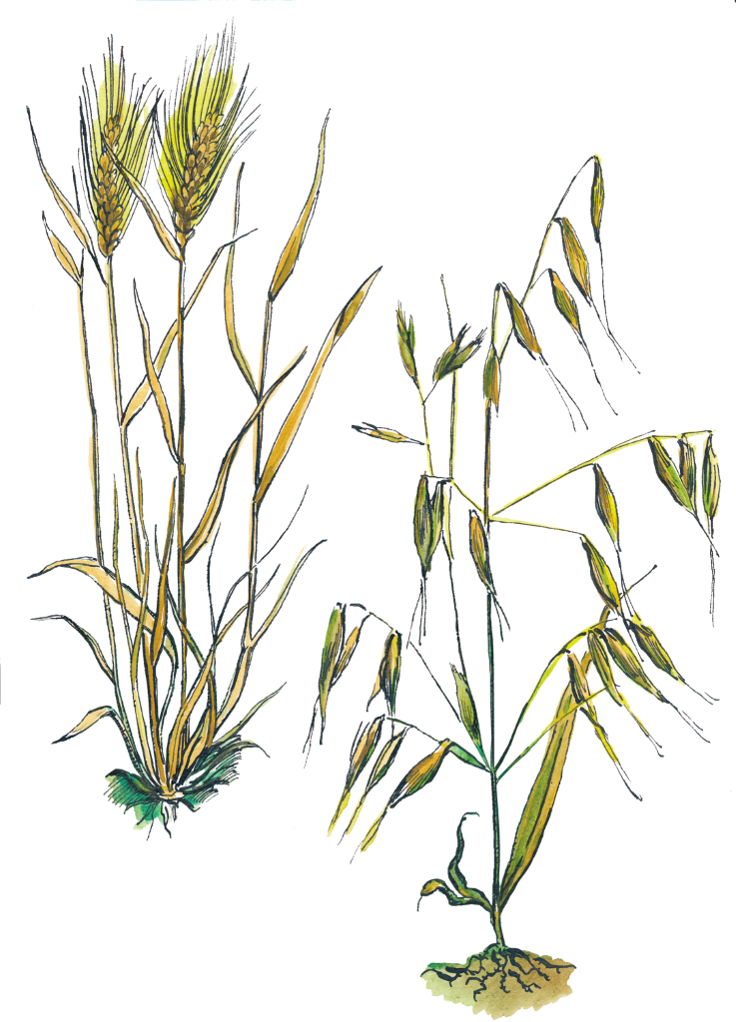



The Montana Harvest of the Month program showcases Montana grown foods in Montana communities. This program is a collaboration between Montana Farm to School, Office of Public Instruction, Montana Team Nutrition Program, National Center for Appropriate Technology, Montana State University Extension, Gallatin Valley Farm to School, FoodCorps Montana, and Montana Department of Agriculture. More information and resources are available at: [www.montana.edu/mtharvestofthemonth](http://www.montana.edu/mtharvestofthemonth/).

Funds were provided in part by USDA Team Nutrition Training grants, Northern Pulse Growers Association, Montana Department of Public Health and Human Services, Montana Pulse Crop Committee, Montana Specialty Crop Block Grant Program.  USDA is an equal opportunity provider. The Montana State University Extension Service is an ADA/EO/AA/Veteran’s Preference Employer and Provider of Educational Outreach. This publication was supported by the Grants or Cooperative Agreements Numbers, 6 U58DP004818-03-01 & 5 U58DP004818-03-00, and funded by the Centers for Disease Control and Prevention. Its contents are solely the responsibility of the authors and do not necessarily represent the official views of the Centers for Disease Control and Prevention or the DPHHS.

*Updated May 19, 2021*

The Montana Harvest of the Month program showcases Montana grown foods in Montana communities. This program is a collaboration between Montana Farm to School, Office of Public Instruction, Montana Team Nutrition Program, National Center for Appropriate Technology, Montana State University Extension, Gallatin Valley Farm to School, FoodCorps Montana, and Montana Department of Agriculture. More information and resources are available at: [https://mtharvestofthemonth.org.](https://mtharvestofthemonth.org/)

Funds were provided in part by USDA Team Nutrition Training grants, USDA funds, USDA Farm to School grants, Montana Healthcare Foundation, Northern Pulse Growers Association, Montana Department of Public Health and Human Services, Montana School Nutrition Association, Montana Department of Agriculture Specialty Crop Block Grant, Montana Grains Foundation, Dairy MAX, Montana Pulse Crop Committee, Montana Wheat and Barley Committee. This institution is an equal opportunity provider and employer. The Montana State University Extension Service is an ADA/EO/AA/Veteran’s Preference Employer and Provider of Educational Outreach.

