**Montana Harvest of the Month logo**

Newsletter + Social Media Content

Beets

Instructions

Please adapt and use the verbiage, logos, and images included below for your newsletter, staff announcements, menus, social media posts, etc. To use the verbiage below, please copy and paste the desired language into your document or social media platform. Be sure to add your site-specific information in the sections with {brackets}. The Montana Harvest of the Month logos and illustrations are included for your use as well. For more information, additional guides and resources, or to download logos and illustrations visit [https://mtharvestofthemonth.org/.](https://mtharvestofthemonth.org/) Registered sites can download all materials on the Harvest of the Month Online Portal.

Announcement/Newsletter Verbiage

**February Harvest of the Month: Beets**

Pick up the beet! Beet roots and their edible leaves are packed with important nutrients including potassium, vitamin A, riboflavin, folate, and magnesium—all great for growing kids and athletes!

Beets are delicious when eaten raw, roasted, steamed, or baked. Grate raw beets for adding color, flavor, and nutrition to salads! These versatile vegetables come in a variety of colors including red, pink, golden, and red and white-striped (Chioggia variety). See which beets you and your family like best! Beets are hardy and are ready to be harvested in the late fall. Beets store well, making them a great vegetable to eat in the cold of winter when many other vegetables are not available locally.

This month, beets from {INSERT TOWN OR FARM HERE IF MONTANA/LOCALLY GROWN} will be featured for {INSERT MEAL} on {INSERT DAY HERE}! Students can vote if they “Tried it, Liked it, or Loved it” after trying the Harvest of the Month item in the {INSERT LOCATION OF VOTING, *remove this section if you are not conducting a voting or a taste-test*}*.*

Social Media Posts

**Suggestions for Social Media Posts: Beets***(Red means Twitter Friendly)*

February’s #MTHarvestoftheMonth is the versatile root vegetable--beets! While some enjoy beets roasted, steamed, raw, or pickled, beet greens can be eaten in a variety of ways as well. For more facts, buying tips, and a fun recipe for heart-shaped beet chips see this month’s Harvest at Home handout: <http://bit.ly/mthombeets>

Don’t yuck my yum, please! Click the link to find out how #FoodCorps Service Member Zack Silver helped a 4-year-old picky eater enjoy February’s #MTHarvestoftheMonth: beets! <http://bit.ly/2d3hwTD>

Pick up the beet! Did you know February’s #MTHarvestoftheMonth is beets, which are packed with many important nutrients like potassium, vitamin A, folate, and magnesium? For more beet fun facts and cooking tips, check out the Harvest at Home handout. <http://bit.ly/mthombeets>

Can you guess how many nutrients #MTHarvestoftheMonth beets are packed with? Harvest at Home handout will tell you!  <http://bit.ly/mthombeets>

Do you know how to properly store beets? Learn beet fun facts, buying tips, and more from #MTHarvestoftheMonth  <http://bit.ly/mthombeets>

Logos and Illustrations

The logos and illustrations included below are also available for registered sites to download on the Harvest of the Month Online Portal. To use the images from this document, copy and paste the images from this document to your document.

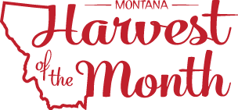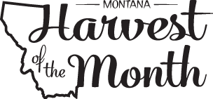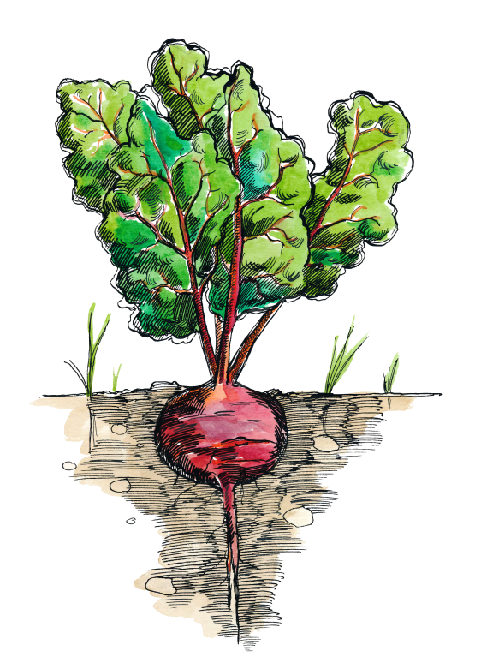

*Updated May 19, 2021*

The Montana Harvest of the Month program showcases Montana grown foods in Montana communities. This program is a collaboration between Montana Farm to School, Office of Public Instruction, Montana Team Nutrition Program, National Center for Appropriate Technology, Montana State University Extension, Gallatin Valley Farm to School, FoodCorps Montana, and Montana Department of Agriculture. More information and resources are available at: [https://mtharvestofthemonth.org/.](https://mtharvestofthemonth.org/)

Funds were provided in part by USDA Team Nutrition Training grants, USDA funds, USDA Farm to School grants, Montana Healthcare Foundation, Northern Pulse Growers Association, Montana Department of Public Health and Human Services, Montana School Nutrition Association, Montana Department of Agriculture Specialty Crop Block Grant, Montana Grains Foundation, Dairy MAX, Montana Pulse Crop Committee, Montana Wheat and Barley Committee. This institution is an equal opportunity provider and employer. The Montana State University Extension Service is an ADA/EO/AA/Veteran’s Preference Employer and Provider of Educational Outreach.



The Montana Harvest of the Month program showcases Montana grown foods in Montana communities. This program is a collaboration between Montana Farm to School, Office of Public Instruction, Montana Team Nutrition Program, National Center for Appropriate Technology, Montana State University Extension, Gallatin Valley Farm to School, FoodCorps Montana, and Montana Department of Agriculture. More information and resources are available at: [www.montana.edu/mtharvestofthemonth](http://www.montana.edu/mtharvestofthemonth/).

Funds were provided in part by USDA Team Nutrition Training grants, Northern Pulse Growers Association, Montana Department of Public Health and Human Services, Montana Pulse Crop Committee, Montana Specialty Crop Block Grant Program.  USDA is an equal opportunity provider. The Montana State University Extension Service is an ADA/EO/AA/Veteran’s Preference Employer and Provider of Educational Outreach. This publication was supported by the Grants or Cooperative Agreements Numbers, 6 U58DP004818-03-01 & 5 U58DP004818-03-00, and funded by the Centers for Disease Control and Prevention. Its contents are solely the responsibility of the authors and do not necessarily represent the official views of the Centers for Disease Control and Prevention or the DPHHS.