**Montana Harvest of the Month logo**

Newsletter + Social Media Content

Beef

Instructions

Please adapt and use the verbiage, logos, and images included below for your newsletter, staff announcements, menus, social media posts, etc. To use the verbiage below, please copy and paste the desired language into your document or social media platform. Be sure to add your site-specific information in the sections with {brackets}. The Montana Harvest of the Month logos and illustrations are included for your use as well. For more information, additional guides and resources, or to download logos and illustrations visit [https://mtharvestofthemonth.org/.](https://mtharvestofthemonth.org/) Registered sites can download all materials on the Harvest of the Month Online Portal.

Announcement/Newsletter Verbiage

**May Harvest of the Month: Beef**

Keep it moooving! Beef packs a powerful nutritional punch. It is an excellent source of protein for building strong muscles and contains important nutrients like iron and B vitamins. Select lean cuts of beef, trim the fat, and drain cooked ground beef to lower the fat content. There are many ways to cook up a healthy meal with beef. Consider making beef fajitas by piling your favorite veggies in a whole-grain wrap with thinly sliced stir-fried beef.

Montana is home to more cattle than people and ranks sixth in the nation for the number of beef cattle. These bovines have been grazing in our nation’s fields since the 1500s. Cattle are ruminants, which means they have four-chambered stomachs that allow them to digest grasses.

This month, beef from {INSERT TOWN OR RANCH HERE IF MONTANA/LOCALLY GROWN} will be featured for {INSERT MEAL} on {INSERT DAY}! Students can vote if they “Tried it, Liked it, or Loved it” after trying the Harvest of the Month item in the {INSERT LOCATION OF VOTING, *remove this section if you are not conducting a voting or a taste-test*}*.*

Social Media Posts

**Suggestions for Social Media Posts: Beef***(Red means Twitter Friendly)*

Keep it moooving! Montana is home to over 2.5 million cows; that’s more than twice the number of people living in our state! Beef is the May #MTHarvestoftheMonth. Learn all about buying and cooking beef from the Harvest at Home handout: <http://bit.ly/mthombeef>

In honor of this month’s #MTHarvestoftheMonth, beef, learn more about the @MTBeeftoSchool Project and what they are doing to increase the availability of local beef in Montana schools and communities! <http://bit.ly/2jjHUXh>

Fun fact: MT is home to more cattle than people, making May’s #MTHarvestoftheMonth a natural choice!

Beef is the #MTHarvestoftheMonth for May. What better time for a Beef and Broccoli Bowl? More facts & recipe here: <http://bit.ly/mthombeef>

Logos and Illustrations

The logos and illustrations included below are also available for registered sites to download on the Harvest of the Month Online Portal. To use the images from this document, copy and paste the images from this document to your document.

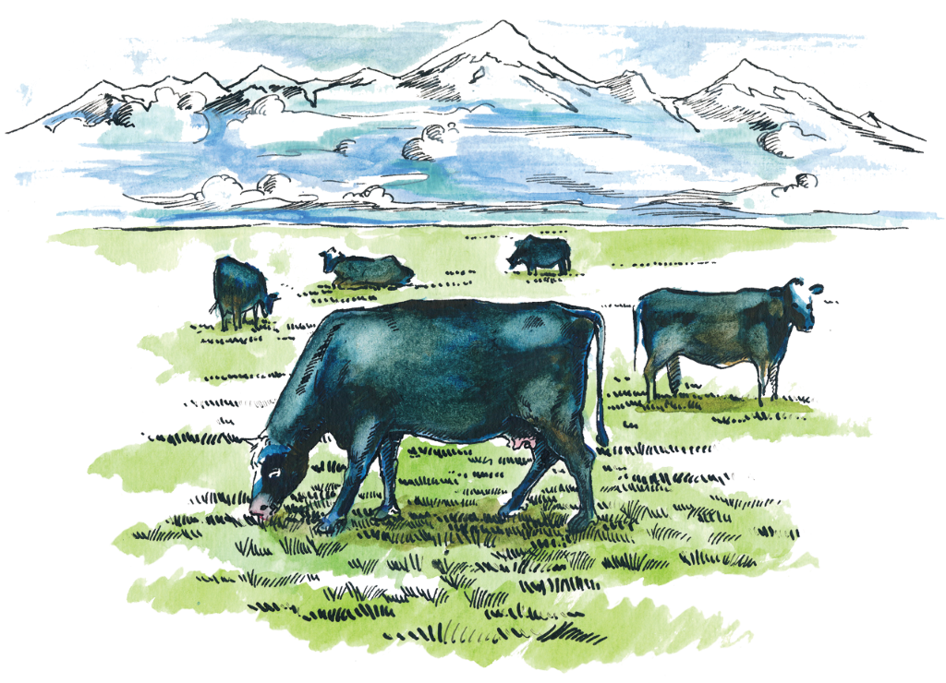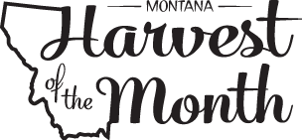

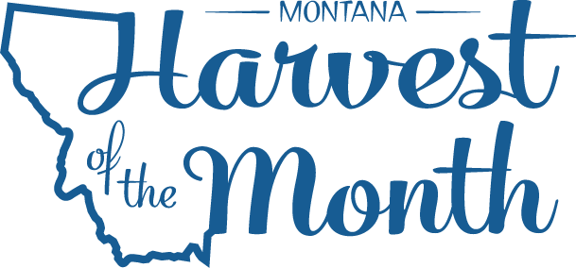

*Updated May 19, 2021*



The Montana Harvest of the Month program showcases Montana grown foods in Montana communities. This program is a collaboration between Montana Farm to School, Office of Public Instruction, Montana Team Nutrition Program, National Center for Appropriate Technology, Montana State University Extension, Gallatin Valley Farm to School, FoodCorps Montana, and Montana Department of Agriculture. More information and resources are available at: [www.montana.edu/mtharvestofthemonth](http://www.montana.edu/mtharvestofthemonth/).

Funds were provided in part by USDA Team Nutrition Training grants, Northern Pulse Growers Association, Montana Department of Public Health and Human Services, Montana Pulse Crop Committee, Montana Specialty Crop Block Grant Program.  USDA is an equal opportunity provider. The Montana State University Extension Service is an ADA/EO/AA/Veteran’s Preference Employer and Provider of Educational Outreach. This publication was supported by the Grants or Cooperative Agreements Numbers, 6 U58DP004818-03-01 & 5 U58DP004818-03-00, and funded by the Centers for Disease Control and Prevention. Its contents are solely the responsibility of the authors and do not necessarily represent the official views of the Centers for Disease Control and Prevention or the DPHHS.

The Montana Harvest of the Month program showcases Montana grown foods in Montana communities. This program is a collaboration between Montana Farm to School, Office of Public Instruction, Montana Team Nutrition Program, National Center for Appropriate Technology, Montana State University Extension, Gallatin Valley Farm to School, FoodCorps Montana, and Montana Department of Agriculture. More information and resources are available at:<https://mtharvestofthemonth.org/>

Funds were provided in part by USDA Team Nutrition Training grants, USDA funds, USDA Farm to School grants, Montana Healthcare Foundation, Northern Pulse Growers Association, Montana Department of Public Health and Human Services, Montana School Nutrition Association, Montana Department of Agriculture Specialty Crop Block Grant, Montana Grains Foundation, Dairy MAX, Montana Pulse Crop Committee, Montana Wheat and Barley Committee. This institution is an equal opportunity provider and employer. The Montana State University Extension Service is an ADA/EO/AA/Veteran’s Preference Employer and Provider of Educational Outreach.

