**Montana Harvest of the Month logo**

Newsletter + Social Media Content

Lentils

Instructions

Please adapt and use the verbiage, logos, and images included below for your newsletter, staff announcements, menus, social media posts, etc. To use the verbiage below, please copy and paste the desired language into your document or social media platform. Be sure to add your site-specific information in the sections with {brackets}. The Montana Harvest of the Month logos and illustrations are included for your use as well. For more information, additional guides and resources, or to download logos and illustrations visit [https://mtharvestofthemonth.org.](https://mtharvestofthemonth.org/) Registered sites can download all materials on the Harvest of the Month Online Portal.

Announcement/Newsletter Verbiage

**December Harvest of the Month: Lentils**

Could you guess that the lentil was one of the first crops cultivated by humans? Today, Montana is the top producer of lentils in the United States, producing nearly 40% of the lentils grown in the United States on 140,000 acres. Lentils are available in many varieties such as red, French Green, and Black Beluga® so you can eat a lentil rainbow! Like other legumes, lentils add nitrogen to the soil, improving soil health. This makes them a good rotational crop with wheat and other grains.

These little gems are healthy for human bodies too! They are an excellent source of fiber and a good source of potassium, protein, iron, and vitamin B6.Gram for gram, lentils provide more potassium than bananas, more iron than ground beef, and have more antioxidants than blueberries! Lentils are very versatile and can be added to soups, salads, wraps, and even baked goods as a puree.

This month, {INSERT TYPE OF LENTIL} from {INSERT TOWN OR FARM HERE IF MONTANA/LOCALLY GROWN} will be featured for {INSERT MEAL} on {INSERT DAY}! Students can vote if they “Tried it, Liked it, or Loved it” after trying the Harvest of the Month item in the {INSERT LOCATION OF VOTING, *remove this section if you are not conducting a voting or a taste-test*}*.*

Social Media Posts

**Suggestions for Social Media Posts: Lentils** *(Red means Twitter Friendly)*

Can you guess which food, ounce for ounce, provides more potassium than bananas, more iron than beef, and more antioxidants than blueberries? Lentils! The December #MTHarvestoftheMonth, truly deserves “superfood” status. Read the Harvest at Home handout to learn more about lentils and find some yummy lentil recipes. <http://bit.ly/mthomlentils>

Did you know that Montana is the top producer of lentils in the nation? December’s #MTHarvestoftheMonth is lentils, which come in many varieties and can be used in countless ways, from hummus to cookies! Read our Harvest at Home handout for a few tips on buying and cooking lentils. <http://bit.ly/mthomlentils>

Did you know that lentils are a good source of fiber, potassium, protein, iron, and vitamin B6? #MTHarvestoftheMonth <http://bit.ly/mthomlentils>

The Harvest at Home handout is your one-stop shop for #MTHarvestoftheMonth lentil facts, cooking tips, & recipes! <http://bit.ly/mthomlentils>

Logos and Illustrations

The logos and illustrations included below are also available for registered sites to download on the Harvest of the Month Online Portal. To use the images from this document, copy and paste the images from this document to your document.

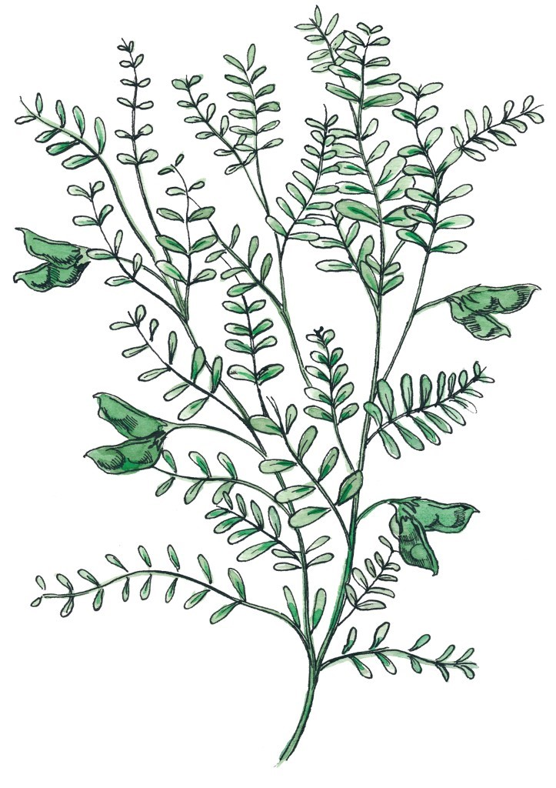

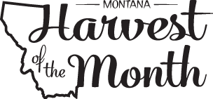

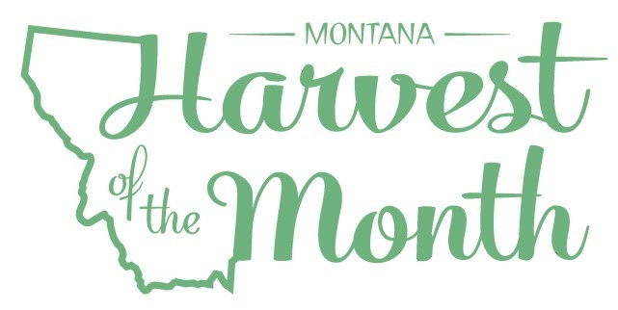 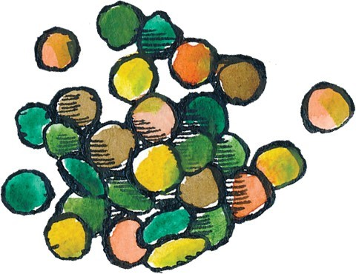

*Updated May 19, 2021*

The Montana Harvest of the Month program showcases Montana grown foods in Montana communities. This program is a collaboration between Montana Farm to School, Office of Public Instruction, Montana Team Nutrition Program, National Center for Appropriate Technology, Montana State University Extension, Gallatin Valley Farm to School, FoodCorps Montana, and Montana Department of Agriculture. More information and resources are available at: [https://mtharvestofthemonth.org.](https://mtharvestofthemonth.org/)

Funds were provided in part by USDA Team Nutrition Training grants, USDA funds, USDA Farm to School grants, Montana Healthcare Foundation, Northern Pulse Growers Association, Montana Department of Public Health and Human Services, Montana School Nutrition Association, Montana Department of Agriculture Specialty Crop Block Grant, Montana Grains Foundation, Dairy MAX, Montana Pulse Crop Committee, Montana Wheat and Barley Committee. This institution is an equal opportunity provider and employer. The Montana State University Extension Service is an ADA/EO/AA/Veteran’s Preference Employer and Provider of Educational Outreach.

