Montana Harvest of the Month logo

Newsletter + Social Media Content

Carrots

Instructions

Please adapt and use the verbiage, logos, and images included below for your newsletter, staff announcements, menus, social media posts, etc. To use the verbiage below, please copy and paste the desired language into your document or social media platform. Be sure to add your site-specific information in the sections with {brackets}. The Montana Harvest of the Month logos and illustrations are included for your use as well. For more information, additional guides and resources, or to download logos and illustrations visit [https://mtharvestofthemonth.org.](https://mtharvestofthemonth.org/) Registered sites can download all materials on the Harvest of the Month Online Portal.

Announcement/Newsletter Verbiage

**January Harvest of the Month: Carrot**

Did you know that carrots were originally purple to black in color, and not orange? Carrots originated in central Asia over one thousand years ago. Today there are over a hundred varieties of carrots that come in many colors--purple, black, yellow, orange, red, and white. In the US, we typically only see orange carrots at grocery stores, but often you can find other colors at farmers markets too.

Carrots are well known for containing high amounts of beta carotene, an antioxidant which is a form of vitamin A. Beta carotene is important for eyesight, skin, and growing bodies. For “x-ray vision” be sure to pack carrots as snacks or add to your meals. Carrots are an easy addition since they are delicious raw or cooked. Grate carrots to add to salad, slaw, or sandwiches. Roast carrots as a delicious side dish or alternative to French fries!

This month, {INSERT TYPE OF CARROT} from {INSERT TOWN OR FARM HERE IF MONTANA/LOCALLY GROWN} will be featured for {INSERT MEAL} on {INSERT DAY}! Students can vote if they “Tried it, Liked it, or Loved it” after trying the Harvest of the Month item in the {INSERT LOCATION OF VOTING, *remove this section if you are not conducting a voting or a taste-test*}*.*

Social Media Posts

**Suggestions for Social Media Posts: Carrot***(Red means Twitter Friendly)*

January’s #MTHarvestoftheMonth is carrots! Did you know that carrots were originally purple to black in color, and not orange? Check out more fun facts and tasty carrot recipes to try on the Harvest at Home handout! http://bit.ly/mthomcarrots

Did you know just one medium-sized carrot can provide over 200% of your daily Vitamin A needs? Enjoy January’s #MTHarvestoftheMonth with this easy carrot fries recipe and learn more: http://bit.ly/mthomcarrots

This January, get all your vitamin A needs with just one yummy carrot every day! #MTHarvestoftheMonth http://bit.ly/mthomcarrots

Did you know the average person eats 17 pounds of carrots per year? #MTHarvestoftheMonth http://bit.ly/mthomcarrots

Logos and Illustrations

The logos and illustrations included below are also available for registered sites to download on the Harvest of the Month Online Portal. To use the images from this document, copy and paste the images from this document to your document.

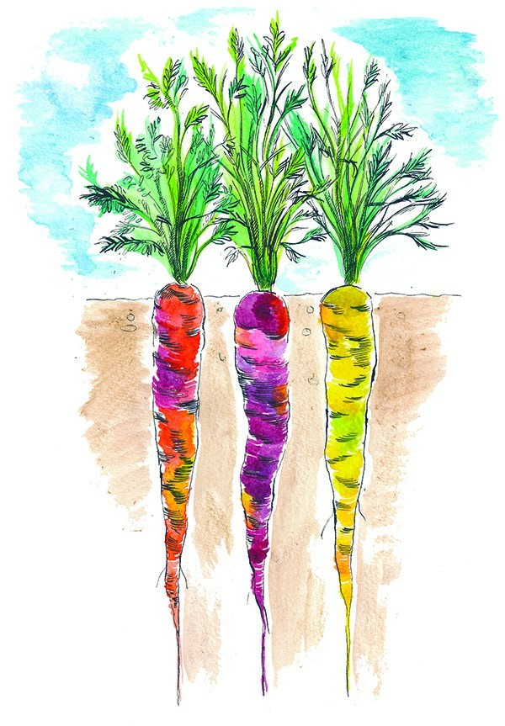 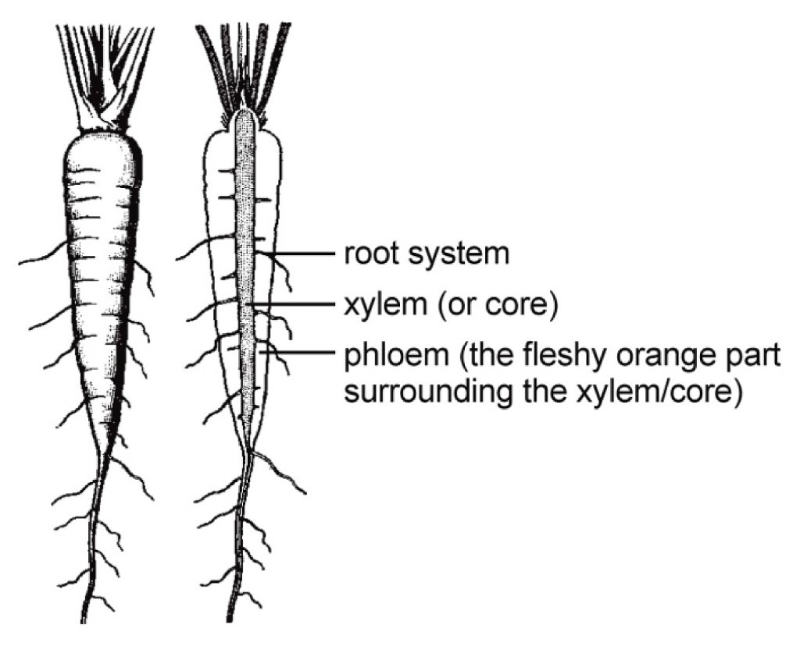

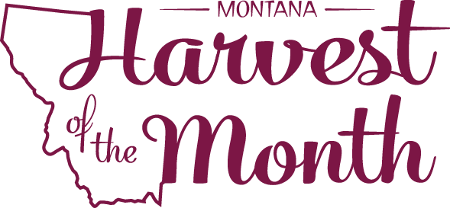  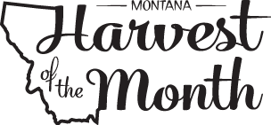

*Updated May 19, 2021*

The Montana Harvest of the Month program showcases Montana grown foods in Montana communities. This program is a collaboration between Montana Farm to School, Office of Public Instruction, Montana Team Nutrition Program, National Center for Appropriate Technology, Montana State University Extension, Gallatin Valley Farm to School, FoodCorps Montana, and Montana Department of Agriculture. More information and resources are available at: [https://mtharvestofthemonth.org.](https://mtharvestofthemonth.org/)

Funds were provided in part by USDA Team Nutrition Training grants, USDA funds, USDA Farm to School grants, Montana Healthcare Foundation, Northern Pulse Growers Association, Montana Department of Public Health and Human Services, Montana School Nutrition Association, Montana Department of Agriculture Specialty Crop Block Grant, Montana Grains Foundation, Dairy MAX, Montana Pulse Crop Committee, Montana Wheat and Barley Committee. This institution is an equal opportunity provider and employer. The Montana State University Extension Service is an ADA/EO/AA/Veteran’s Preference Employer and Provider of Educational Outreach.



The Montana Harvest of the Month program showcases Montana grown foods in Montana communities. This program is a collaboration between Montana Farm to School, Office of Public Instruction, Montana Team Nutrition Program, National Center for Appropriate Technology, Montana State University Extension, Gallatin Valley Farm to School, FoodCorps Montana, and Montana Department of Agriculture. More information and resources are available at: [www.montana.edu/mtharvestofthemonth](http://www.montana.edu/mtharvestofthemonth/).

Funds were provided in part by USDA Team Nutrition Training grants, Northern Pulse Growers Association, Montana Department of Public Health and Human Services, Montana Pulse Crop Committee, Montana Specialty Crop Block Grant Program.  USDA is an equal opportunity provider. The Montana State University Extension Service is an ADA/EO/AA/Veteran’s Preference Employer and Provider of Educational Outreach. This publication was supported by the Grants or Cooperative Agreements Numbers, 6 U58DP004818-03-01 & 5 U58DP004818-03-00, and funded by the Centers for Disease Control and Prevention. Its contents are solely the responsibility of the authors and do not necessarily represent the official views of the Centers for Disease Control and Prevention or the DPHHS.